

**ONLINE LEARNING**

**Software requirements specification**

**Hanoi, September 2021**

**CLASS SE1509 TEAM 2**

**Team member:**

* Bui Hoang Phong
* Nguyen Duc Cuong
* Do Ngoc Hoang Anh
* Nguyen Thi Thanh Mai (Leader)
* Nguyen Cong Quan

**Table of Contents**

**Overview** **4**

1. Introduction 4

2. System Function 5

3. Common Requirement 19

**Functional requirement** **20**

1. Common Feature 20

a. User Login 20

b. User Register 20

c. Reset Password 21

d. User Authorization 22

e. User Profile 22

f. Change Password 22

2. Public Feature 23

a. Home 23

b. Blog List 25

c. Blog Details 26

d. Course List 27

e. Course Details 28

f. Course Register 29

3. Customer Feature 29

a. My Registration 29

b. My Course 30

c. Lesson View 31

d. Quiz Lesson 33

4. Learning Feature 34

a. Quiz Handle 34

b. Quiz Review 35

5. Marketing Feature 36

a. Dashboard 36

b. Post Details 37

c. Slider List 38

d. Slider Details 39

6. Course Content Feature 40

a. Subject List 40

b. New Subject 41

c. Subject Details 42

d. Subject Dimension 44

e. Price Package 45

f. Subject Lesson 45

g. Lesson Details 46

7. Test Content Feature 47

a. Question List 47

b. Question Details 49

c. Question Import 49

d. Quizzes List 50

e. Quiz Details 52

8. Sales Feature 52

a. Registration List 52

b. Registration Details 53

9. Admin Feature 54

a. User List 55

b. User Details 56

c. Setting List 56

d. Setting Details 57

1. **Overview**

**1.**     **Introduction**

The Online Learning System is built to support the Organization and multiple Experts to create and sell their online courses, and the customer can learn the course with the videos, documents included as they purchase the course made by Experts.

The main advantage of this system is that customers can learn anytime, anywhere, by using various types of devices such as smartphones, tablets and computers. This can be an alternative way for customers (Especially students) to study.

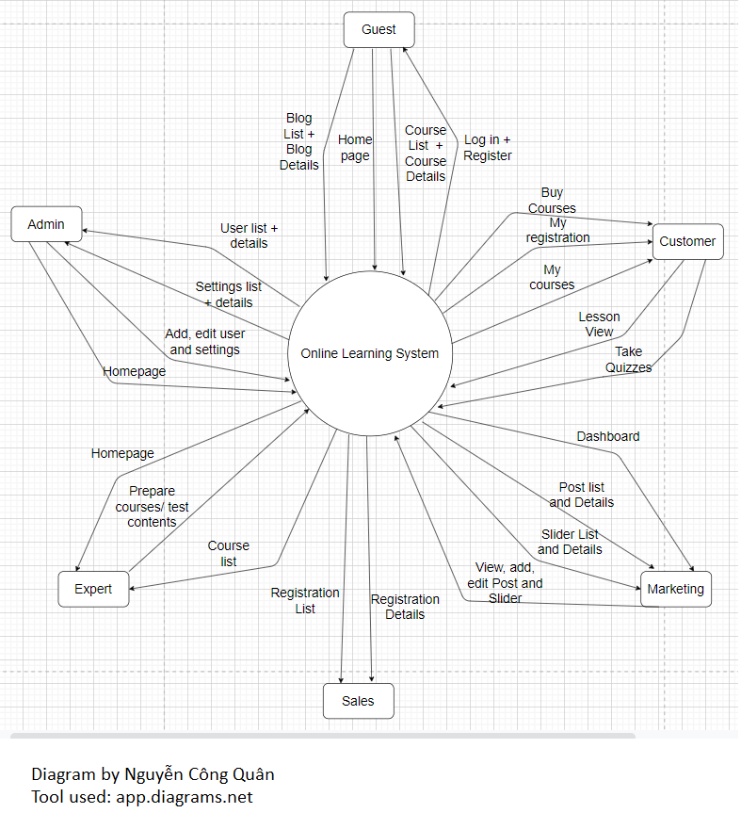

[**Link to this diagram**](https://viewer.diagrams.net/?tags=%7B%7D&highlight=0000ff&edit=_blank&layers=1&nav=1&title=fordiagram.drawio#R7V1Jd6M4EP41OTpPiP2YpZdD8pJJerp75jKPNorNBIMHcMfOrx8JEEYlvASzOMGnIFkRpuqrT1WlEj5Tr2bLL5Ezn96GLvHPMHKXZ%2Br1GcZYwRb9w3pWWY9imHbWM4k8N%2B9bdzx6ryTvRHnvwnNJLAxMwtBPvLnYOQ6DgIwToc%2BJovBFHPYU%2BuJd586ESB2PY8eXe394bjLNei0drfu%2FEm8y5XdWUP7JzOGD84546rjhS6lL%2FXSmXkVhmGRXs%2BUV8Zn0uFyy%2F%2Fu84dPii0UkSPb5h%2FnN%2FT%2Ffb1cP%2F5L53V2iPNz5365H%2BSy%2FHX%2BRP%2FBd4HsBoX03xIkCL5jQy8dVnJBZ%2FhjJisuGzk%2FVQBuXL1MvIY9zZ8w%2BeaFQoH3TZObTlkIvnXie6ebJWxL6dS6fwiDJdc0EcSk%2FC%2F9iJErIstSVP9sXEs5IEq3okAJruZxzpGlc7i9rtWEr75uWVFZ0OjlUJsXca2nSi1ygbxAuloT7ZUHiRJJjFC4Cl8klFdYOWbYgOhXpguhGFaJTcIXojLYkZ0mS%2B0pn5uYK5UcfMxGFFCdR%2BEyuQj%2BMaE8QBgykT57vgy7H9yYBbY6p8Ajtv2RC86j1X%2BQfzDzX9TchfK031I1iMJIVo1VBui29cBsrKebSDxlF3HgM2PRj%2BtyGz9TxKxK0ZPy3YEyXimkUp3K6oAPojZapsPjn9GrC%2FubzXpPE8fx4ODqHPKbYfetcprGrcBHFpNC64cyYaIJf8TyVQYYCVIwanA41DOxW6VuHhqTDm9S8vKBQ1wOZUG1SaQ5GTboqmlr%2F9GrKpraIEzq7rJW%2BnQYLCE%2FV%2BnYaFNlrkKRGAveCRQUMlL4Tx954u6DI0kt%2BMgSe2xpv%2F5W2sa7n7etlDtG0sSo17knk0Wdj0M%2F6AvqcP8uNbC6dN9dTpS0%2B10Z1xZRix2SbTLJxiRNNSLIH8ogrhEOy9kva1SuUy%2Fsi4juJ91sMoqo0nt%2FhPvSCpGSZBgAX9NGzB8%2F%2Fqxz0gIkMsJqqKpgok4w0EQWJsyoNm7MB8eYvbEBrsIRgjF5kM67RXcj0AMDbEuBvV6nwGZNHVAFhMBw2N%2FTdhNQpm2PZWW6Sj2xN4CNNtRviI%2BXERtvZSDMbYiMNYm8DGzVFGFhO96SEMU499QE56Ia2QRG9cYUcZDXIFVqZKpRzhNUDqOLctvQzwX0xEd5BGWkLTnkAj5j7Eslx8wh0hWvziNKOV2Na4n14wNSqV0PBKcWqJI6ZK4O%2Be%2BRlOCxlYiD%2BvuNTrLXJUqZeZqntDFViI2SLbGThXeHUiY0q2Uhvio1QO2xkbWcjeTw0H3v7eBM4BQbqgu10yaS%2BOc8sa%2FrHwnt9HZJTZppAX0bfdCdnTW%2Bd6Jkk6a7oseXjgBXaqiy9bvNxWM7HXTvx9FfoRO6AUK2KewFG3%2Fs5HBcltdyH6eadn%2B3hOQFVz%2FA2bWD%2ByKxQVKUBtacpeW149D2XbQbw%2Fdah6gqkWy2zd13JudgsWLlid3Pd7IK4HtNabm%2BZ8rhKh6I7HS5UVRtHnTKiJjPio%2BNXuF59r%2FEYeEiKUpG36naR1%2BSUoiS2%2BiGhago5bvuQFPc5FtNWvWe5OeyONB5UEMwq1Q0IbYi%2BltPcGpYw%2BSBsieWr51AYF4NA2K5YLbslXDnF1yBpaKYlprvRjmTSdtowLLPMGyN0jjS14wzTR2EUmBmqzSgwV9U2o8iJT8Aog3PBVRuoxOqbVORo6dNyTp%2Fn6Ny4kQIymf3narQWa6eUEhujrUxcnyG58t9ZDl4BDGnXJUhYNWx1TZBy%2BHsfEabJs1J5wWemofQEBDuvk5A83T8MwhwVR4O4jiqqggtAdEKZHCSNWj33nIoyomOpceQccaS2b9atBoC2b7ZUDaDAFV88cNbO%2Fpgu5xeKcwX%2BoKI4IH2r730EXQ7iLtyZJ1ec9u5uYVhNXEW8nbpbequFFMgUXK5zrPD)

**2.**      **System Function**

1. **Screen Flow**

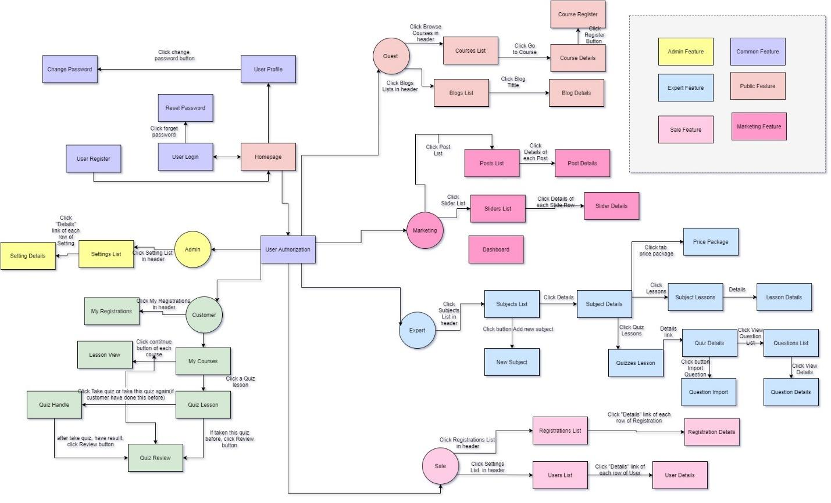

[**Link to this diagram**](https://viewer.diagrams.net/?tags=%7B%7D&highlight=0000FF&edit=_blank&layers=1&nav=1&title=screenflow.drawio#R7Z1bd5s6Fsc%2FTR49C4mL8WPi9DJrpTNp0zOnfSRGtmkx5ACuk376EUayQXJjQhDakZ2XBBkI%2FuvH1tbeulzY09Xjhyx4WH5KQxJfYCt8vLCvLzDGCPv0V1nyVJUgbzypShZZFLKyfcFd9JuwQouVrqOQ5I0TizSNi%2BihWThLk4TMikZZkGXppnnaPI2b%2F%2FUhWBCp4G4WxHLp31FYLKtS37X25R9JtFjy%2F4ws9skq4CezgnwZhOmmVmS%2Fu7CnWZoW1V%2BrxymJS%2FW4LtV17%2F%2Fw6e7BMpIUbS7w0htn%2Bu2z%2Fc%2B3nz9iP7Q2X6fBiN3lVxCv2Rf%2BmK4Ie%2BDiiauQpeskJOWN0IV9tVlGBbl7CGblpxta8bRsWaxi9vE8TQpWkdihx%2FKD8v9KsoI81orYg38g9BmK7Imewj7lcjOKsMOON%2FsqQVznZa06PFYWMAoWuzvvhaJ%2FMK1eoBuWdPsrJxktuc3SeRSDV3CnljYFbUnBm3QRJdCFs8e6hXMk4b6QRZQXJX7AtBvhpniu9vfWPSBeToryxQ3yfJNmITgRkQtNRE8S8V0YFYCNH2oqOPJ0KziWFJwug4R6IpA5dKCp6EsqXsXpgpbcUHMITj9b0M%2FWLd9Eku9uff%2BjdKJVKEgNQzxN4zTb3ssOA%2BLPZ7Q8L7L0J6l94s18cj9Xozm2dIvOTVFN9U%2FlA0%2FTdZb3bDkFyefzOZ4dlDz07j3X66vNH%2FtNzbXbCST3cvakX5MiiOLcANhd120IjyaubuFlJ38Le%2BWwZkERpT07%2FDCQt33tyMu9BNY2KuFdgakeIf22Wu4t3JA8L5m1%2FheRjQnouthuWmvtgQEkdy8%2Br6PfpVPCxDdPdVu7M4hkZ%2Fo%2FJeHWrqU0rn30tTePsgfOOtLmiD4eC06Jo1t1LHvgtX6PehOjR3esX3fZC9%2B1puY44RNRd%2B1OeHm9oPtlGNKCZGvfjSFeVF5%2F9wfL3R9m340RHSEXHO9y14f5j7EhQS0BdEd7RwnLHSUmeWiMYXf9pur6E4FY7ihVhr3S3jjFHe1RFSznbZhBN0Ry3wIHudxHYiMtlFvzuT8jh2MB977ruFZfwUPuoIHB3JZ7SJVhqZQ3T3J3ol1yuXPEMB%2BiazSQ7I41hka63DdiBn1tCOruBJx1kXtFd6QookRN5h6GhfH0Wxi5W7SX3WAjA0B5uXfEw7y8At6%2B7KKdASD7n7pHBqkumhkfaVdd7iJJQpMkvCyH5tOjWRzkeVQJFWSFXPyM5OQxKr7RA%2BtfLjv6zs4s%2F74uNbL4wRM%2FSOiXrF1UHn6vf7a%2FbHvEr%2FtjZeXpOpuRZwThkxaCbEGK54SrziNhYz6CXPW1mnUPVCwvy0gcFNEv0njYQ7XN%2FsNtGiXFnizEAREH8fBbVN%2BbXbVnRrqROPZyd8xvVAkj3WgL3%2B5rv4JHOa%2FZjscXg2d1Ag9pBw%2BfwVMCnhy4OBHwcEvwxmfwVIDHx1GdwfvTeZ6Z4AkD6IbGTo5g9YddHbodgkewQ3Xoagzqa2gnoLjbhXl5rF8EprXBO8KvavDwGbwjXQtYfQtjwJMDmYoaWmh9Wm7JjpNnwSKP2wpGzBh3JK853N8bDwyeHNk6EfC4JTsOHiwfTwTP8%2FsBzx4YvK7BvZ6b2tdbLqBcuG5HLugXE%2B40tPuvMs42CBrQvCRlaEitnmo0lEbCLKrTC5x0enBLsoh%2BJ5KJzdhgjrvd2nPHZjLZbMZca1gg%2BVPrtlUawHPagueewVMAnsIYGeoCnjUUeG0NHiz3zLaECEPX%2FqItLr81cI%2FRVRiq6AYetCyoDwo8NBF4mXQET0oKOAODJ48666%2BpBZ2M8luCx1dqAEIeFk2eaKlakyeu2Thwr8NVGCQboq3tcf7HUVbbhnP5QjpnVntmVUVcrW8f7zgdsNpQR8yri8HSN0OHwtCaaZYMtYYVVk8DixPv%2BPHLYRXmY7vCjVTDqiLYpx%2B844M7YGU6PXEZCtyRJ)

1. **Screen Details**

| **No** | **Function/Screen** | **Feature** | **Function/Screen Details** |
| --- | --- | --- | --- |
| 1 | User Login | Common | This is a pop-up screen which allows the user to enter email & password to login; on this page, there are also options for user to register new information or reset the password for the case s/he forget it |
| 2 | User Register | Common | This is a pop-up screen which allows the user to register himself/herself to the system by inputting following information: full name, gender, email, mobile; User then need to verify by clicking the link sent via email to him/her before being able to access the system |
| 3 | Reset Password | Common | The user input his/her email to receive the reset password link. This link is sent to the user's email for his/her password resetting.  - On clicking the link, the user is redirected to the password resetting page in which s/he input new password (twice) for the system access  - Note that the link is only available for a specific time duration as configured in the system config file. |
| 4 | User Authorization | Common | Implementation of authorization mechanism in the system, including the specify the role of logged-in user, his/her authorized page links (building the displayed menu items (in the front end) and preventing unauthorized access via enter the links directly) |
| 5 | User Profile | Common | This is a pop-up screen which allows the user to edit his/her profile information, including the registered ones & the avatar image. Please note that s/he is not allowed to change the email |
| 6 | Change Password | Common | This is a pop-up screen which allows the user to change his/her password by inputting his current password as well as new password (twice) |
| 7 | Home | Public | Show sliders, hot posts, featured subjects + the sider with the latest posts, static contacts/links  - Shown slider information includes its image and title; the user is redirected to the slider's backlink on his/her clicking  - Shown post information includes its thumbnail, title, post date; the user is redirected to the post's details on his/her clicking  - Shown subject information includes its thumbnail, title, tag line; the user is redirected to the subject's details on his/her clicking |
| 8 | Blogs List | Public | Show the posts pagination (sorted by updated date) + the sider with the post search box, posts categories, latest posts, static contacts/links; Shown post information includes its thumbnail, title, category, brief-info; the user is redirected to the post's details on his/her clicking |
| 9 | Blog Details | Public | Show post details (including title, author, updated date, category, and post details) + the sider with the post search box, posts categories, latest posts, static contacts/links |
| 10 | Courses List | Public | Show the subjects paginated (sorted by updated date, paginated) + the sider with the subject search box, subject categories, featured subjects, and static contacts/links;  - Shown subject information includes its thumbnail, title, tag line, lowest price package option (list price, sale price);  - The user is redirected to the subject's details on his/her clicking on the subject  - The user can choose to register to the subject by clicking the Register button |
| 11 | Course Details | Public | Show subject details (including title, tag line, brief info, lowest price package option (original price, sale price), product description, and a Register button) + the sider with the subject search box, subject categories, featured subjects, static contacts/links |
| 12 | Course Register | Public | This is a pop-up screen which allows the user to register for access to a subject. On this screen, the user needs to choose appropriate subject price package & input his/her information (full name, email, mobile, gender); A logged in user doesn't have to input those contact information |
| 13 | My Registrations | Customer | Show the list of user's registration + the sider with the subject search box, subject categories, static contacts/links  - Each registration includes below information: id, subject, registration time, package, total cost, status, valid from, valid to;  - If the registration is still in the submitted status, the users can choose to cancel it or coming back to the Course Register pop-up to edit it) |
| 14 | My Courses | Customer | for the customer to view his/her access-allowed courses |
| 15 | Lesson View | Customer | allow customer to access the course lessons for his/her studying |
| 16 | Quiz Lesson | Customer | This allows the user to take the topic quiz or view the quiz results |
| 17 | Quiz Handle | Learning | This screen allows the user to browse and answer the quiz questions |
| 18 | Quiz Review | Learning | This screen allows the user to review the details of the quiz that s/he has just taken |
| 19 | Dashboard | Marketing | Show statistics of new subjects (new, all), new registrations (success, cancelled, submitted), revenues (total, by subject categories), customers (newly registered, newly bought), and the trend of order counts (success, all) by day for the last 7 days (the start date & end date can be adjustable) |
| 20 | Post Details | Marketing | Show detailed post information (thumbnail, category, title, brief information,  description, flag to turn the featurning on/off, status), from that allow the user to input, view or edit them |
| 21 | Sliders List | Marketing | Show the paginated list of sliders (including sliders' id, title, image, backlink, status)  - The user can filter the sliders by the status + search by title or backlink  - For each slider, the user can choose to hide, show, edit it |
| 22 | Slider Details | Marketing | Show detailed slider information (image, title, backlink, status, notes) |
| 23 | Subjects List | Course Content | Show the list of course paginated. The shown information for each subject include the id, name, category, number of lessons, owner, and status  The user can:  - Filter the list by course category & status  - Search the course by the name  - Choose to add new course (redirect the user to the New Subject page for that)  - Edit course information (linked to the Subject Details for that) |
| 24 | New Subject | Course Content | The screen is shown with below information for the user to input new course information: name, thumbnail image, category, featured flag, owner, status, and description |
| 25 | Subject Details | Course Content | This page allows the admin and the assigned expert to access and prepare the subject information, including the course general information, the dimension, and price package. Only the admin can change the status to Published or Unpublished + add/edit the price packages |
| 26 | Subject Dimension | Course Content | This page allow the admin/expert to input or edit subject dimension information, including the following detailed information: type, name, description |
| 27 | Price Package | Course Content | This page allows the admin to input or edit subject dimension information, including the following detailed information: name, access duration (in months), status (read-only), list price, sale price, description. The expert can only view the information. |
| 28 | Subject Lessons | Course Content | This page shows the list of lessons for a selected package. On this page, the admin/expert is allowed to activate/deactivate, or call the Lesson Details for adding new or editing existing lesson |
| 29 | Lesson Details | Course Content | This page allows the admin/expert to input/edit the lesson information |
| 30 | Questions List | Test Content | The existing questions list for a specific subject/course are shown here (paginated). On this screen, the admin/expert is allowed to filter the questions by the subject, lesson, dimension(s), level, status + search the questions by content  Below information is shown for each question in the list: id, content, subject /dimension /lesson, level, status + options to show, hide, edit it; The page also allows the user to import the question (redirect him/her to the Questions Import pop-up screen. |
| 31 | Question Details | Test Content | This page allows the admin/expert to input or edit questions information, including following information: subject, dimension(s), lesson, status, content, media (image, audio, video – with preview option), answer options (with the key marked + ability to add, edit, delete), and explanation |
| 32 | Question Import | Test Content | This is a pop-up screen which allows the user to choose the import file and then import the questions in the file into the questions bank. The screen also provides the option for the user to download the sample import template. |
| 33 | Quizzes List | Test Content | The existing quizzes are shown in this page pagination:  - The user can filter the list by subject, quiz types + search quizzes by the name  - Each quiz includes following information: id, name, subject, level, # question, duration, pass rate, and the quiz type.  From this page, the user has the option to call to the Quiz Details page for adding new or editing existing quizzes + delete the quiz. Please note that the quiz can be edited only when there is not any test taken yet. |
| 34 | Quiz Details | Test Content | This page allows the user to input or edit quiz information |
| 35 | Registrations List | Sale | Show the list of users' registrations  - Each registration includes below information: id, email, registration time, subject,  package, total cost, status, valid from, valid to, last updated by;  - The user can filter the list by subject (searchable), registration time (from, to), status + can search by the email  - The list can be sorted by id, email, registration time, subject, package, total cost, status, valid from, valid to  - From the list, the user can choose to add new or edit an existing registration via the Registration Details screen as below |
| 36 | Registration Details | Sale | Show detailed registration information (subject, package with list price/sale price, full name, gender, email, mobile), registration time, sale, status, valid from, valid to, notes) from that for the user to add new or change the status of a registration with relevant notes (if a registration is created by the user, then s/he can edit other registration information). On changing a registration status to Paid, if the user with relevant registered email does not exist, the system would create one and send back to the user the login information (link, email, pass) along with the other notification notes |
| 37 | Users List | Admin | Show the paginated list of registered users (include users' id, full name, gender, email, mobile, role, status):  - The admin can filter the users by gender, role, status  - Allow the admin to search users by full name, email, mobile  - The list is sortable by id, fullname, gender, email, mobile, role, status  - From each user, the admin can choose to view or edit it  - The page also have the button/link that allows the admin to add new user |
| 38 | User Details | Admin | Show detailed user information (avatar, full name, gender, email, mobile, role, address, status), from that allow the user to add new, view or edit user information  - After adding, new generated login password would be email to the new user  - The admin can only edit/update the role and status of the user |
| 39 | Settings List | Admin | Show the paginated list of settings (include settings' id, type, value, order, status):  - The admin can filter the setting by type, status  - Allow the admin to search settings by value  - The list is sortable by id, type, value, order, status  - From each setting, the admin can choose to view, activate/deactivate, or edit it  - The page also have the button/link that allows the admin to add new setting |
| 40 | Setting Details | Admin | Show detailed user information (type, value, order, description, status), from that allow the user to add new, view or edit setting information |

1. **User Authorization**

| Screen | Guest | Customer | Marketing | Sales | Expert | Admin |
| --- | --- | --- | --- | --- | --- | --- |
| User login | X | X | X | X | X | X |
| User registration | X | X | X | X | X | X |
| Reset Password | X | X | X | X | X | X |
| User Profile | X | X | X | X | X | X |
| Change Password | X | X | X | X | X | X |
| Home | X | X | X | X | X | X |
| Blog List | X | X | X | X | X | X |
| Blog Details | X | X | X | X | X | X |
| Course List | X | X | X | X | X | X |
| Course Details | X | X | X | X | X | X |
| Course Register | X | X |  |  |  |  |
| My Registrations |  | X |  |  |  |  |
| My Courses |  | X |  |  |  |  |
| Lesson View |  | X |  |  |  |  |
| Quiz Lesson |  | X |  |  |  |  |
| Quiz Handle |  | X |  |  |  |  |
| Quiz Review |  | X |  |  |  |  |
| Dashboard |  |  | X |  |  |  |
| Post details |  |  | X |  |  |  |
| Slider list |  |  | X |  |  |  |
| Slider details |  |  | X |  |  |  |
| Subject List |  |  |  | X |  | X |
| New Subject |  |  |  | X |  |  |
| Subject details |  |  |  | X |  |  |
| Subject Dimension |  |  |  | X |  |  |
| Price package |  |  |  | X |  |  |
| Subject lesson |  |  |  | X |  | X |
| Lesson details |  |  |  | X |  |  |
| Question list |  |  |  | X |  | X |
| Question details |  |  |  | X |  |  |
| Question import |  |  |  | X |  |  |
| Quiz list |  |  |  | X |  | X |
| Quiz details |  |  |  | X |  |  |
| Registration list |  |  |  |  | X |  |
| Registration details |  |  |  |  | X |  |
| User list |  |  |  |  |  | X |
| User details |  |  |  |  |  | X |
| Setting list |  |  |  |  |  | X |
| Setting details |  |  |  |  |  | X |

*There are six types of users supported in the system:*

-        **Guest**: Unregistered or non logged in users.

-        **Customer**: Registered users, are actual customers or potential customers.

-        **Marketing**: The members in the marketing teams of the organization.

-        **Sale**: Sale members of the organization.

-        **Expert**: Users who access and prepare the course and test contents, assigned by admin.

-        **Admin**: The leader and manager of the organization, and the Administrator of the system.

**User’s feature:**

*Common features:* These are features shared by all types of users, including login, register, reset password, user authorization based on role, view and edit profile, change password.

*Public features:* These are accessible features when using as guests, including homepage, blogs list, blog details, course list, course details and course register.

*Exclusive features by roles:*

| **Role** | **Features** |
| --- | --- |
| Customer | They can view all courses they purchased, they can study all these courses and take quiz lessons of the courses in multiple choices. |
| Marketing | They can manage posts and sliders by add, filter, search, show, hide, view details. |
| Sales | They can view information about customers and registration details. |
| Expert | Their role is to prepare courses as ordered by the administrator, they can only see their assigned courses. |
| Admin | He / She can view all the information of all users, add a new or edit existing users, and he/ she also can alter all the settings in the system. |

**3. Common Requirements**

a. Configuring information  
- All the user-configured data as listed below are defined and stored as the system setting(s)  
1: User Roles  
2: System Menu  
3: Post Categories  
4: Subject Categories  
5: Test Types (Simulation, Lesson-Quiz)  
6: Question Levels (Hard, Medium, Easy)  
7: Lesson Types (Subject Topic, Lesson, Quiz)  
8: Subject Dimension (Domain, Group)  
- Those are managed via the Settings List & Setting Details as mentioned above (in the part 2.g)  
- Other once-configured data are managed via the system config files (as mentions in the relevant

b. User Input data formats  
The types & format (length, validation, etc) of the input data are suggested by the project  
team and need to be mentioned clearly in the analysing & designing documents.  
- Those must be agreed by the supervisor (teacher) before implementing.  
- Once agreed, those must be implemented accordingly in the software input validating, data  
showing and in the system database

**II. Functional Requirements**

1. **Common Feature**

The common functions/screens used for all types of users, as listed below

1. **User Login**

* Function trigger: when user click the “Login” button on the menu
* Function description: authenticate the user to give him/her to access authorized features later on.
* Screen Layout:

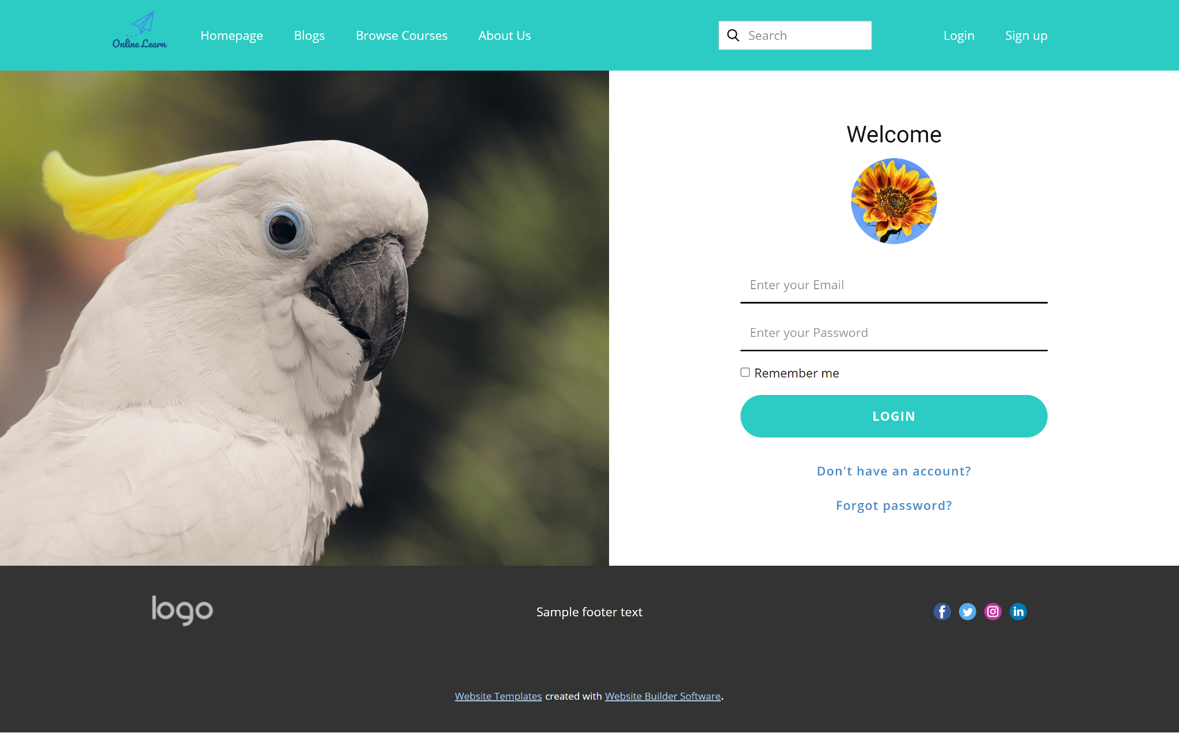

* Function Details: This is a pop-up screen which allows the user to enter email & password to login; on this page, there are also options for users to register new information or reset the password in case s/he forgets it.

1. **User Register**

* Function trigger: : when user click the “Register” button on the menu
* Function description:Register new user to login to system.
* Screen Layout:
* 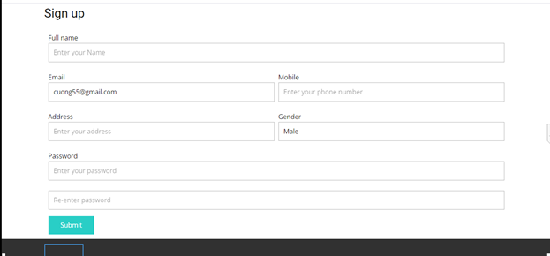
* Function Details:
* System will redirect the user to the Register User page automatically after clicking to the register user at the login page.
* Users have to input Full Name, Email, Mobile, Address, Gender, Password.
* The Email must be a valid format of email and not registered before.
* Mobile must follow the pattern.
* Password and Re-password text box must match.
* Fullname can not be blank.

1. **Reset Password**

* Function trigger: by clicking the link “Reset Password” in Login screen
* Function description: use in case the user forgot his/her password
* Screen Layout:

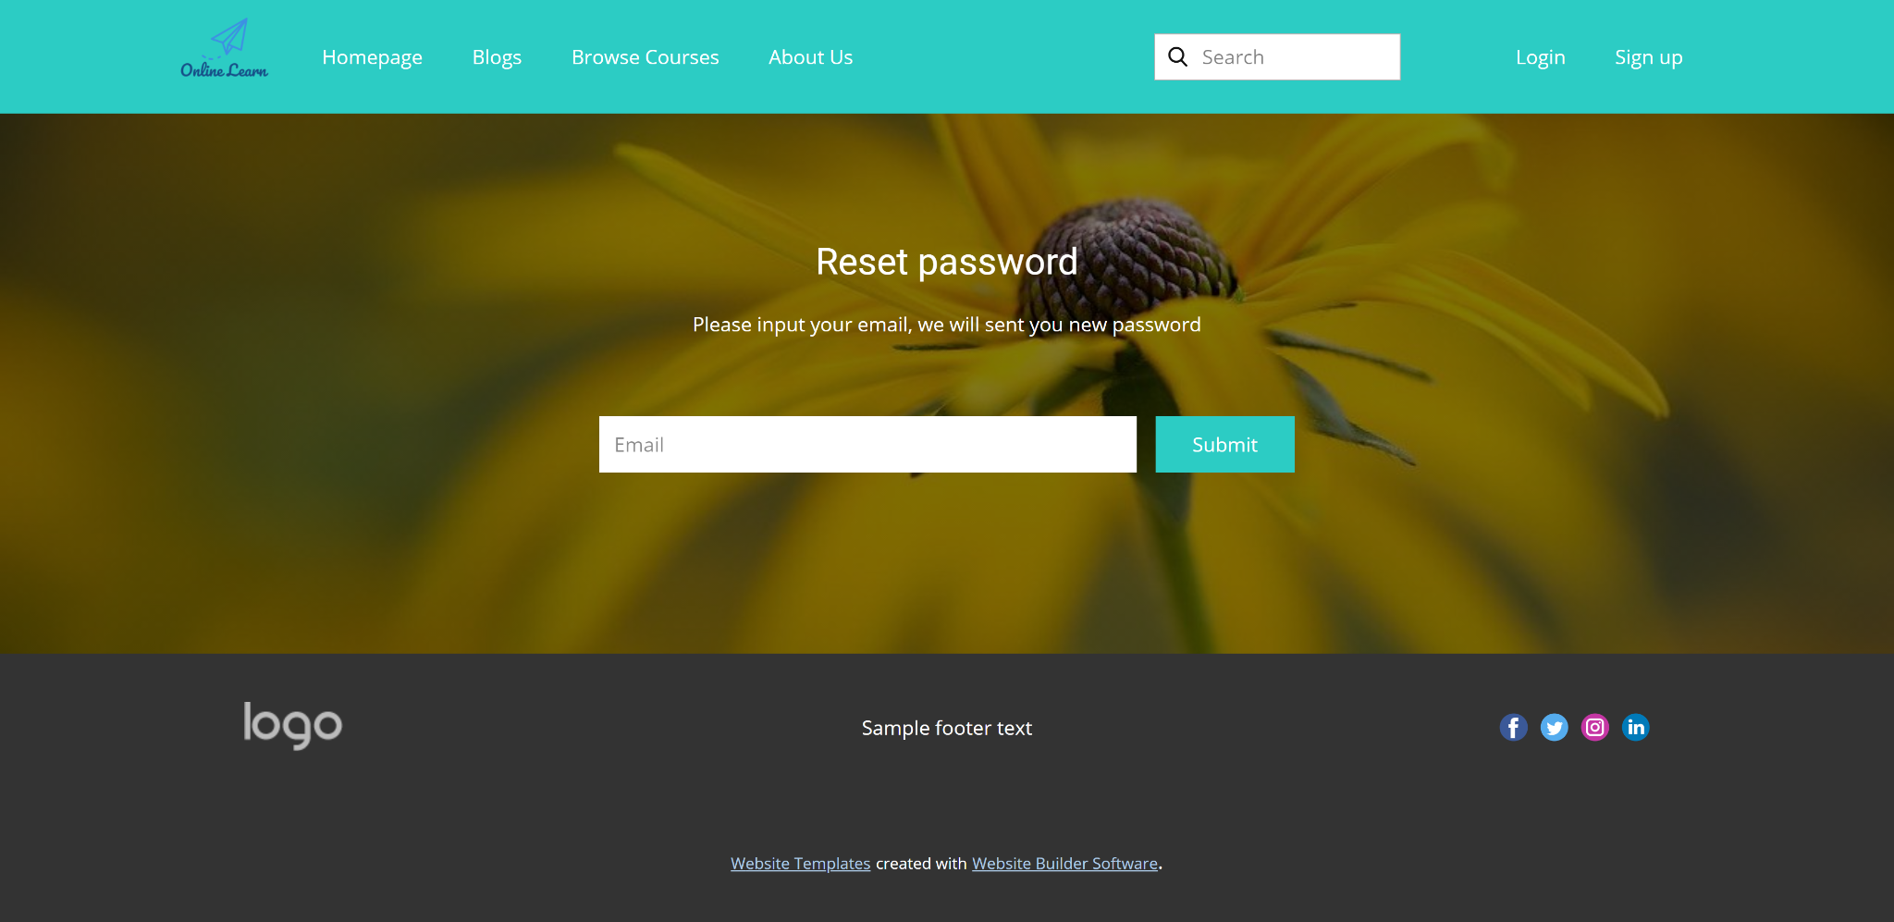

* Function Details: "The user to input his/her email to receive the reset password link. This link is sent to the user's email for his/her password resetting.
  + On clicking the link, the user is redirected to the password resetting page in which s/he input new password (twice) for the system access
  + Note that the link is only available for a specific time duration as configured in the system config file. "

1. **User Authorization**

* Function trigger: for different user
* Function description: authorize user into the system functions based on his/her role
* Screen Layout: non screen
* Function Details: Implementation of authorization mechanism in the system, including the specify the role of logged-in user, his/her authorized page links (building the displayed menu items (in the front end) and preventing unauthorized access via enter the links directly)

1. **User Profile**

* Function trigger: Click to User avatar at header
* Function description: Let user view their registered information
* Screen Layout:

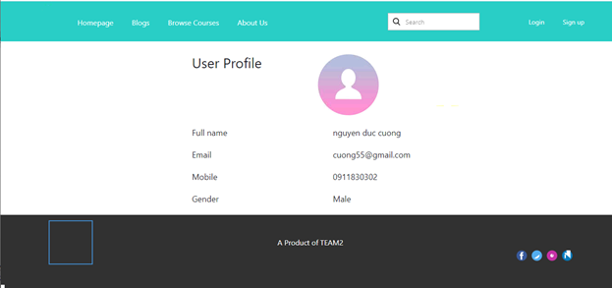

* Function Details:
* System will redirect the user to the User Profile page automatically after click to the avatar at the header.
* Information includes Fullname, Email, Mobile, Gender, User avatar.

1. **Change Password**

* Function trigger: when user click button “Change Password” in User Profile
* Function description:
* Screen Layout:

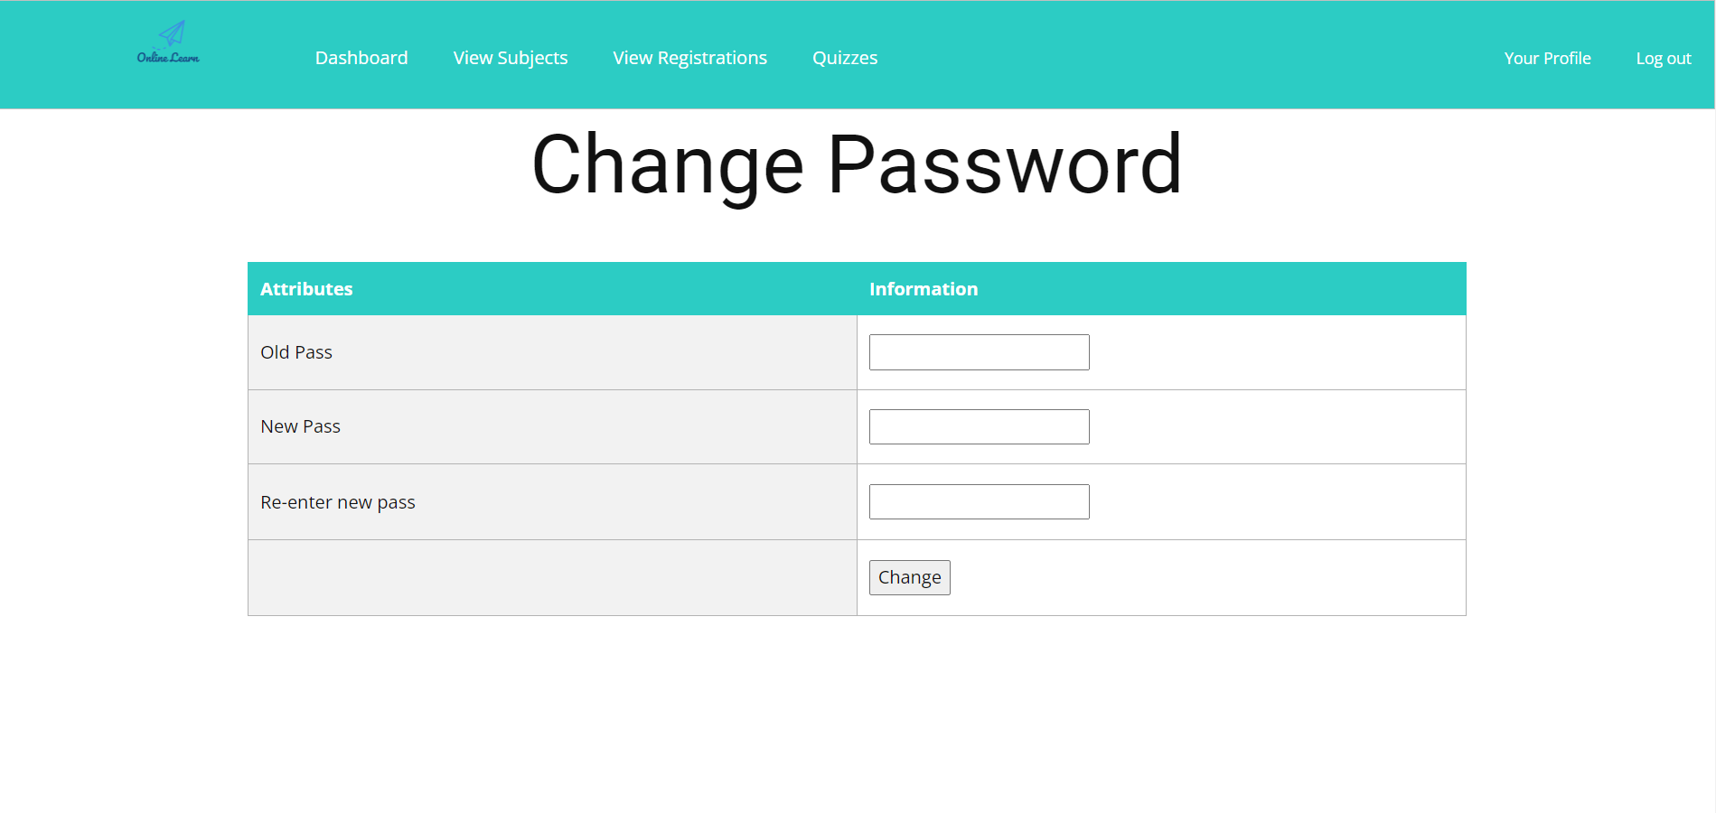

* Function Details: This is a pop-up screen which allows the user to change his/her password by inputting his current password as well as new password (twice).

1. **Public Feature**

This feature includes the screens used for the Guests

* 1. **Home**
* Function trigger: From running the web application
* Function description:  The starting page of the system. Show general information about online learn
* Screen Layout:
* 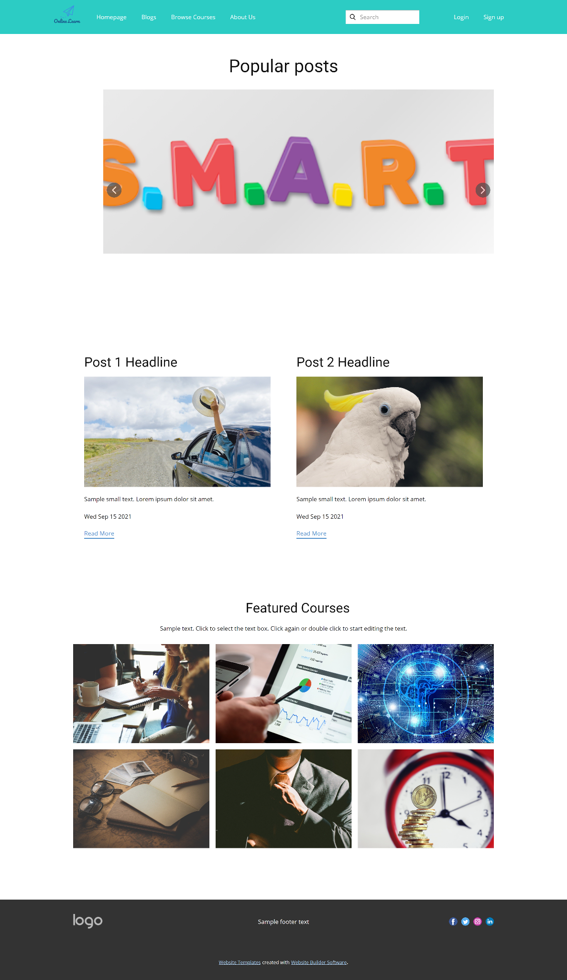
* Function Details: "Show sliders, hot posts, featured subjects + the sider with the latest posts, static contacts/links
* Actor: Guest

| **Screen Details** | | | |
| --- | --- | --- | --- |
| **#** | **Field Name** | **Type** | **Description** |
| 1 | Read more | HyperLink | This hyperlink links to  Post Details screen |
| 2 | Image | HyperLink | This hyperlink links to  Course Details screen |
| 3 | Category Title | Label | Title of category value: posts, subjects, sliders |
| 4 | Slide Show | SlideShow | Slideshow of services |

| **Main flows** | | |
| --- | --- | --- |
| **Step** | **Actor** | **Action** |
| 1 | Guest, Customer | Access Online Learn System |
| 2 | System | Display Homepage screen |

* 1. **Blogs List**
* Function trigger: when user click the “Blog List” link from Home Page
* Function description: list of shared posts
* Screen Layout:
* 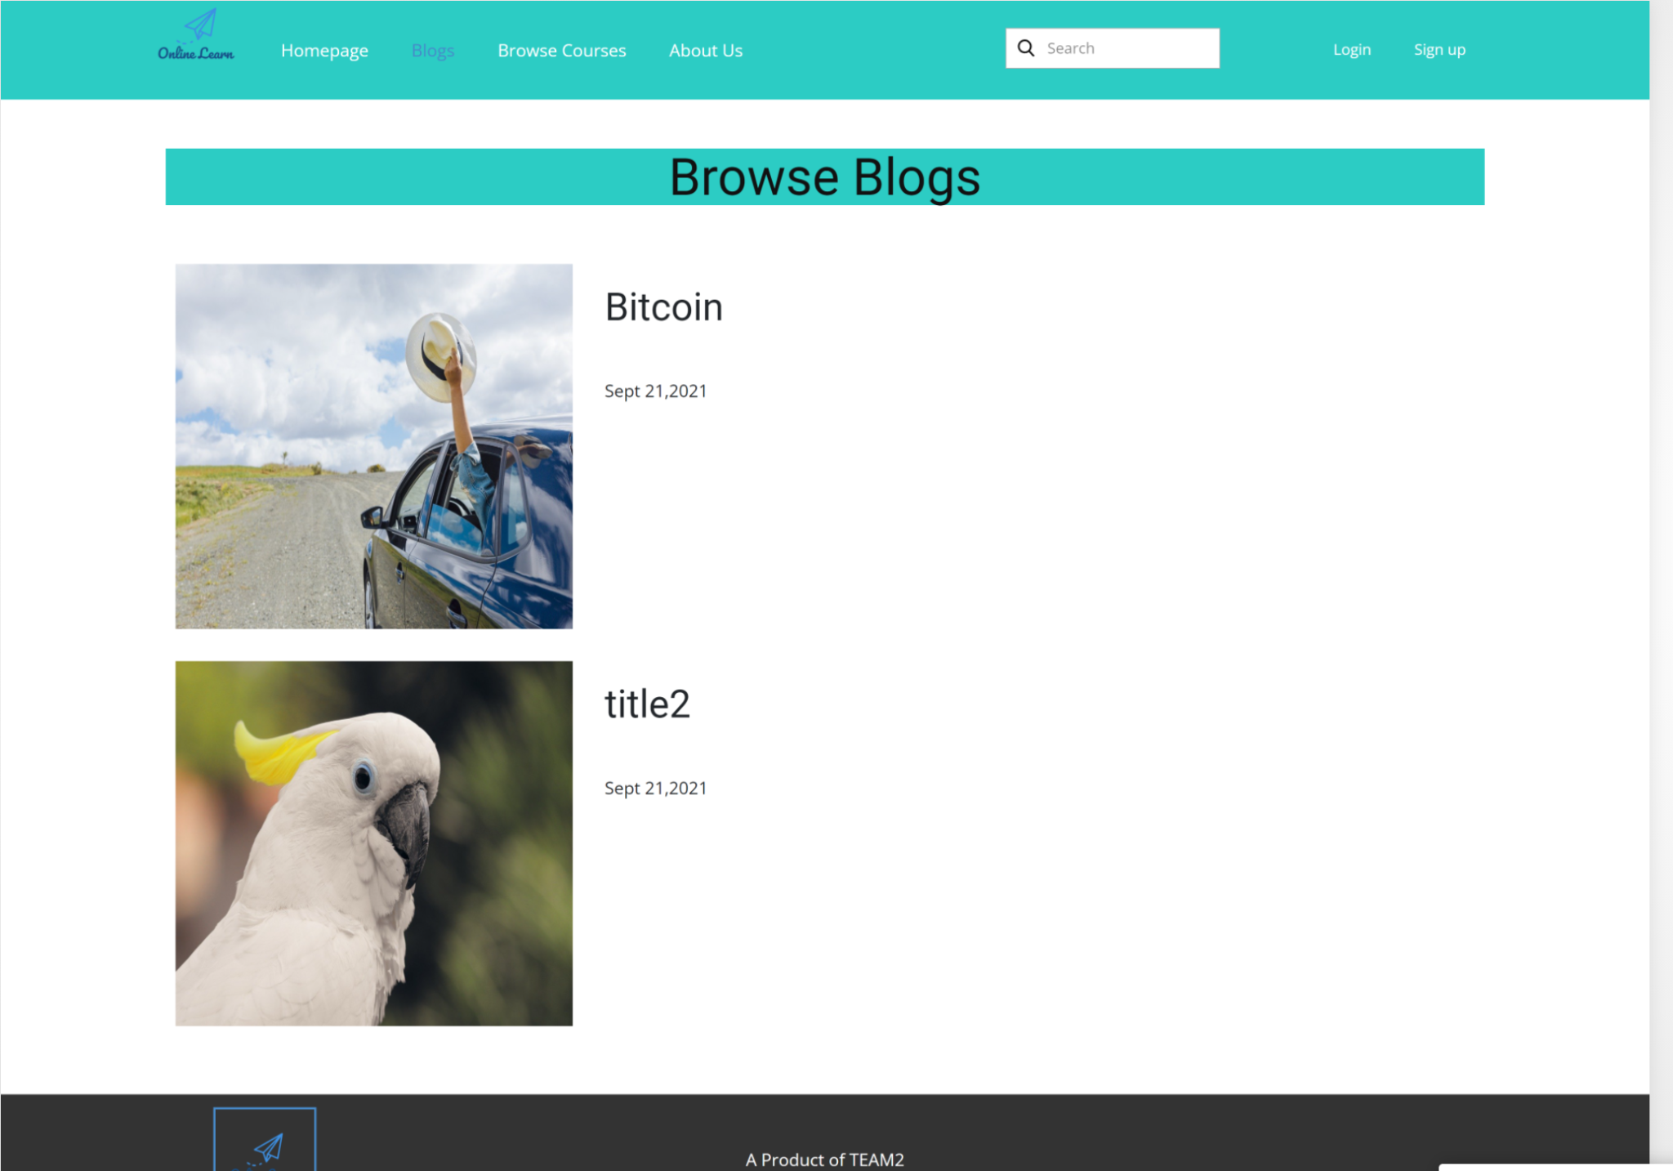
* Function Details: Show the posts pagination (sorted by updated date) + the sider with the post search box, posts categories, latest posts, static contacts/links; Shown post information includes its thumbnail, title, category, brief-info; the user is redirected to the post's details on his/her clicking
  1. **Blog Details**
* Function trigger: Click to Detail at Blog list page
* Function description:View Blog detail and change Blog detail
* Screen Layout:

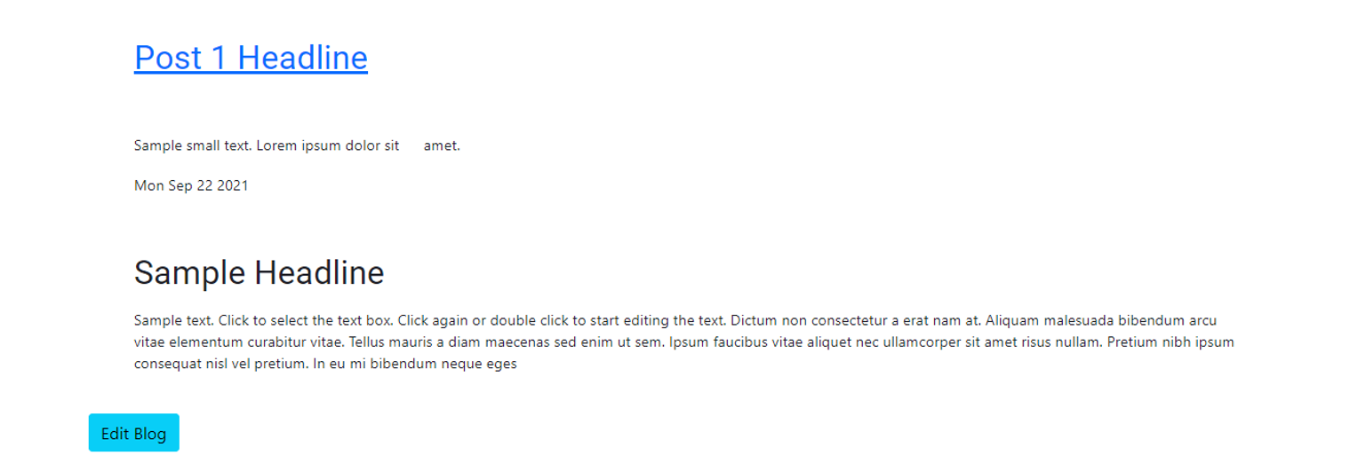

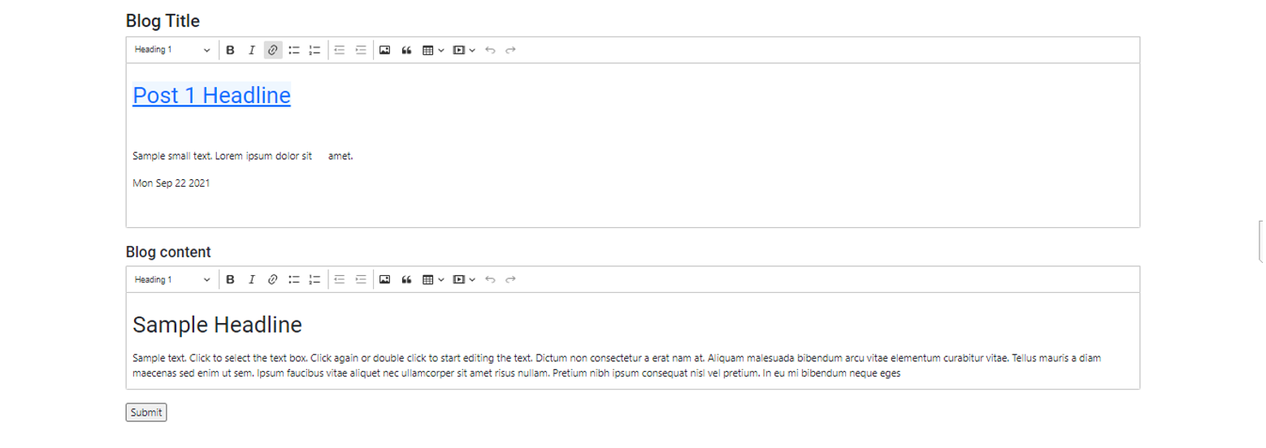

* Function Details:
* System will redirect the user to the Blog Detail page automatically after clicking to the Detail.
* User can change Lesson name, type, subjectID, Video link, Content by change the value in text box and click button submit
  1. **Courses List**
* Function trigger: when click the “Browse Course” from menu Homepage
* Function description: list of the active courses
* Screen Layout:

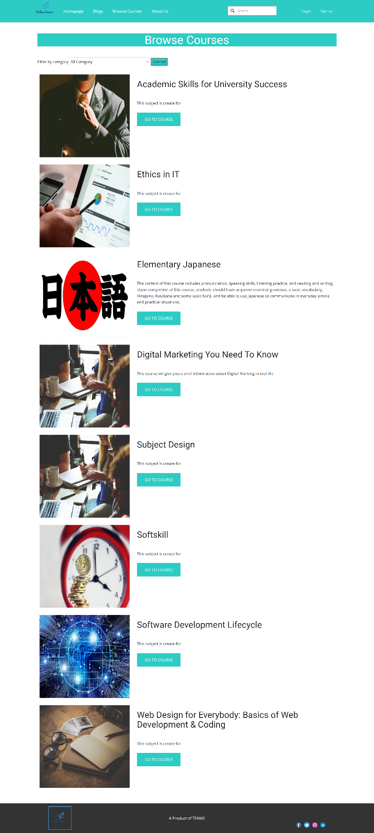

* Function Details: "Show the subjects paginated (sorted by updated date, paginated) + the sider with the subject search box, subject categories, featured subjects, and static contacts/links;

Shown subject information includes its thumbnail, title, tag line, lowest price package option (list price, sale price);

The user is redirected to the subject's details on his/her clicking on the subject

The user can choose to register to the subject by clicking the Register button"

| **Screen Details** | | | |
| --- | --- | --- | --- |
| **#** | **Field Name** | **Type** | **Description** |
| 1 | Go to course | Button | This button links to  Course Details screen |
| 2 | Image | Image | Image of each course |
| 3 | Course’s Title | Label | Name of courses |
| 4 | Slide Show | SlideShow | Slideshow of services |

| **Main flows** | | |
| --- | --- | --- |
| **Step** | **Actor** | **Action** |
| 1 | Guest | Click “Browse Courses” in header |
| 2 | System | Display first pagination of Course List |
| 3 | Guest | Choose a category from drop down list |
| 4 | System | Display the following list of course of that chosen category |

Alternative flows: Select category

| **Step** | **Actor** | **Action** |
| --- | --- | --- |
| 1 | Guest | Choose a category to view course of that category |
| 2 | System | Display list of course have that category |

* 1. **Course Details**
* Function trigger: click a course from Courses List
* Function description: details of the selected course
* Screen Layout:

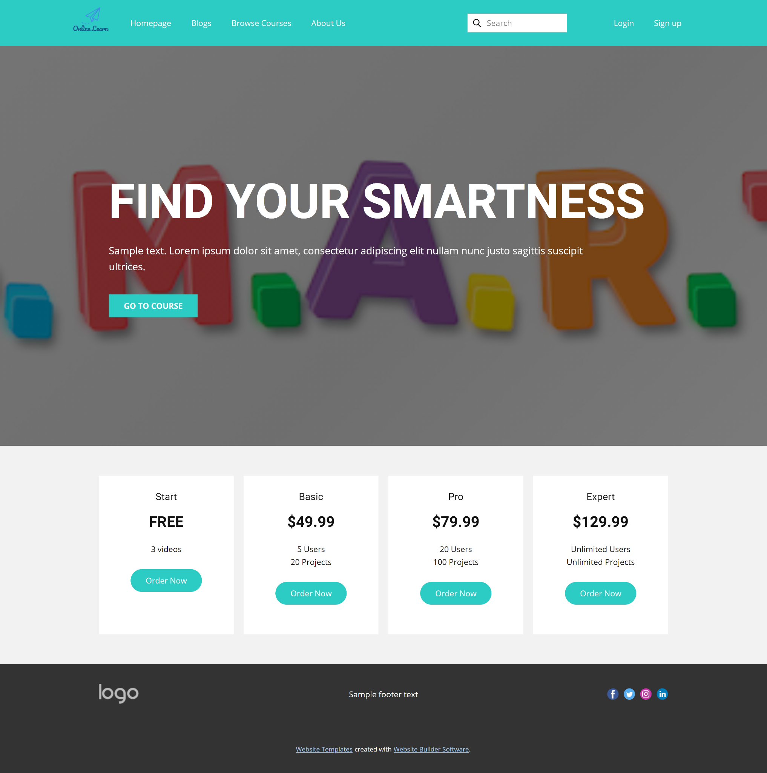

* Function Details: Show subject details (including title, tag line, brief info, lowest price package option (original price, sale price), product description, and a Register button) + the sider with the subject search box, subject categories, featured subjects, static contacts/links
  1. **Course Register**
* Function trigger: click “Register to this course” button in the Course Details
* Function description: allow the user to register to access a course with a specific price package
* Screen Layout:
* 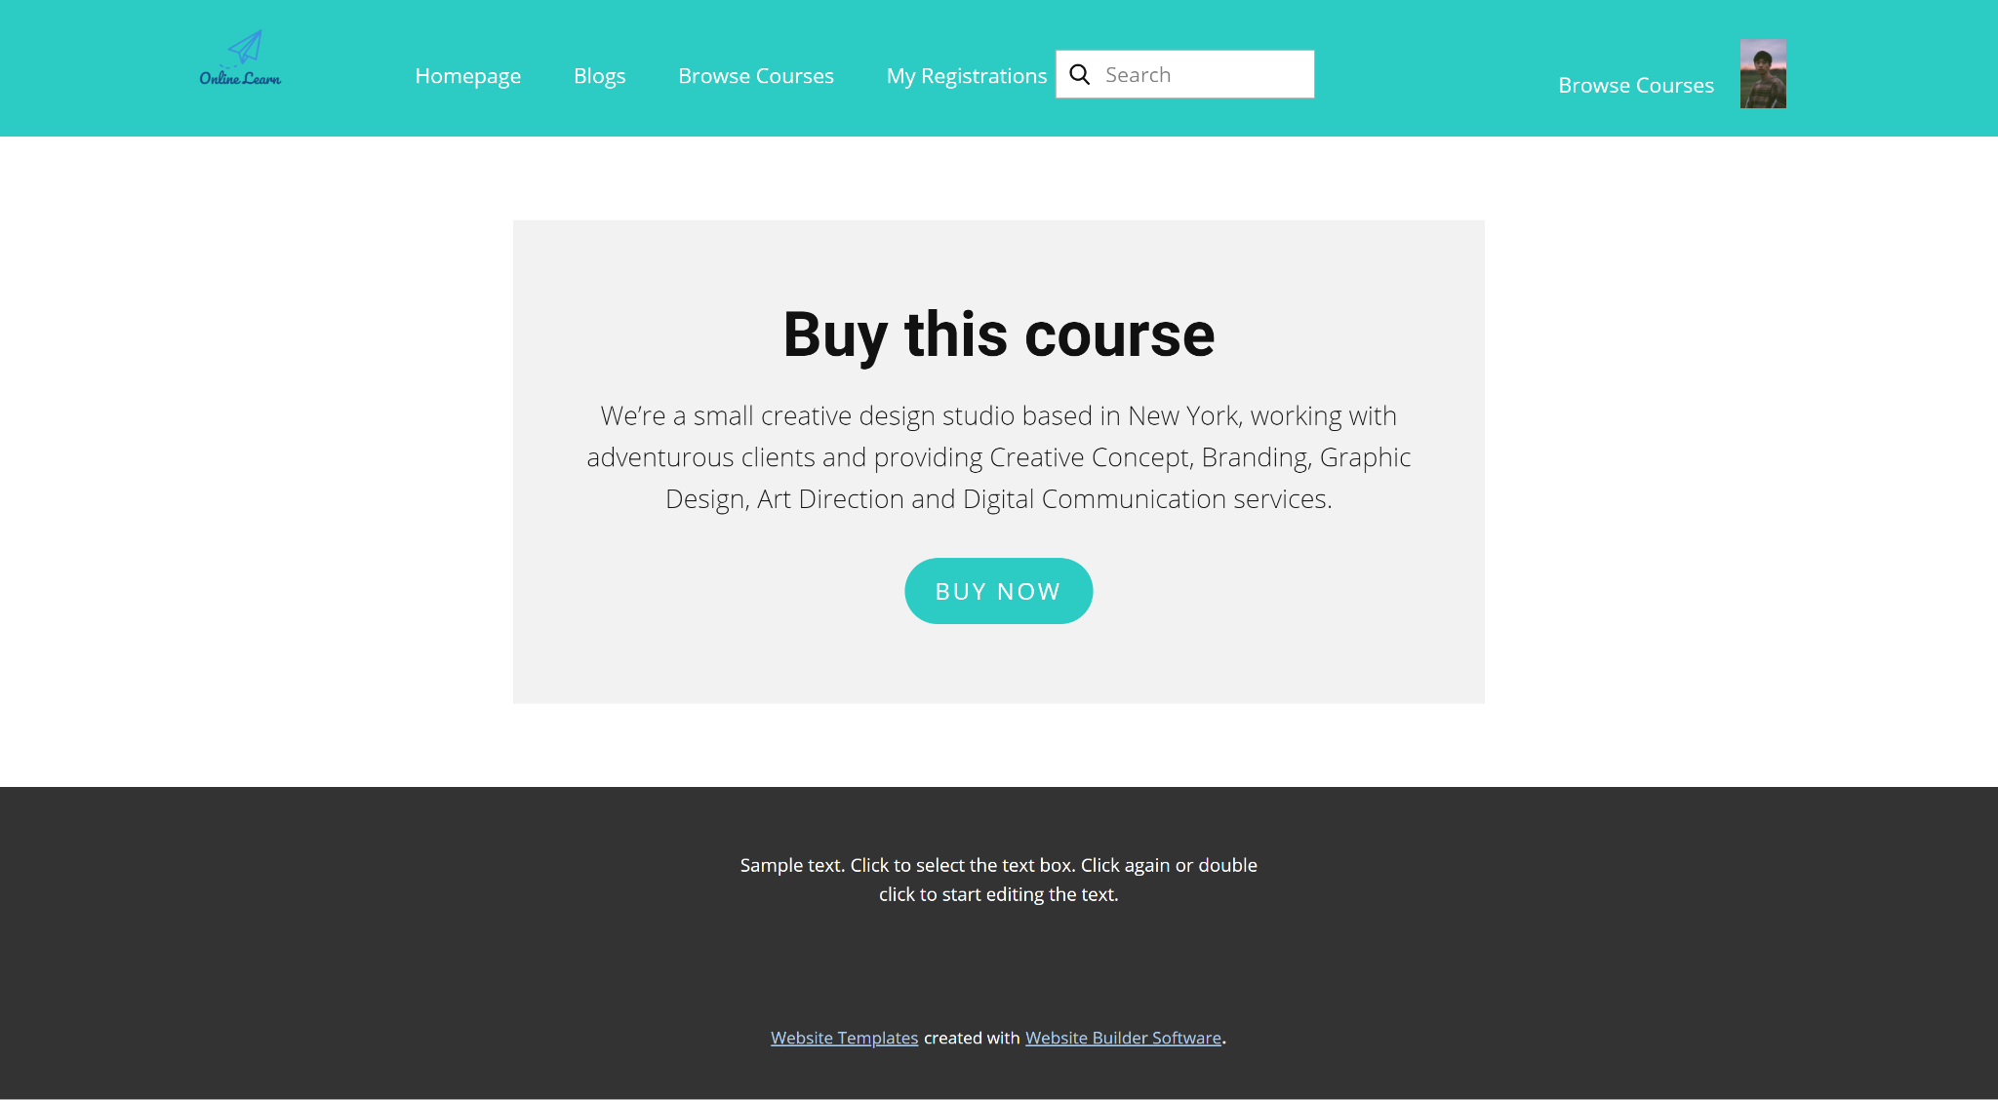
* Function Details: This is a pop-up screen which allow the user to register for access a subject. On this screen, the user needs to choose appropriate subject price package & input his/her information (full name, email, mobile, gender); A logged in user doesn't have to input those contact information

1. **Customer Features**

This includes the screens used for the system customers, as listed below

* 1. **My Registrations**
* Function trigger: when user click “My Registration” from Menu
* Function description: for the customer to view his/her submitted course registrations
* Screen Layout:
* 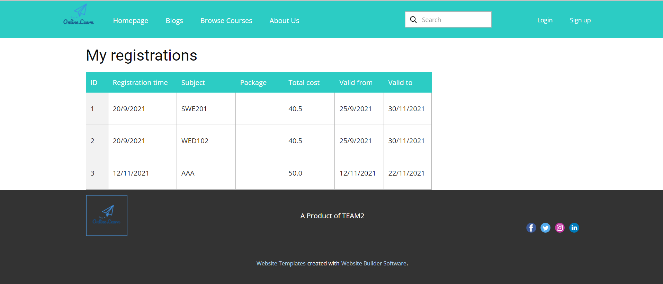
* Function Details: "Show the list of user's registration + the sider with the subject search box, subject categories, static contacts/links
  + Each registration includes below information: id, subject, registration time, package, total cost, status, valid from, valid to;
  1. **My Courses**
* Function trigger: when user choose “My Course” from Homepage menu
* Function description: for the customer to view his/her access-allowed courses with below screen layout
* Screen Layout:
* 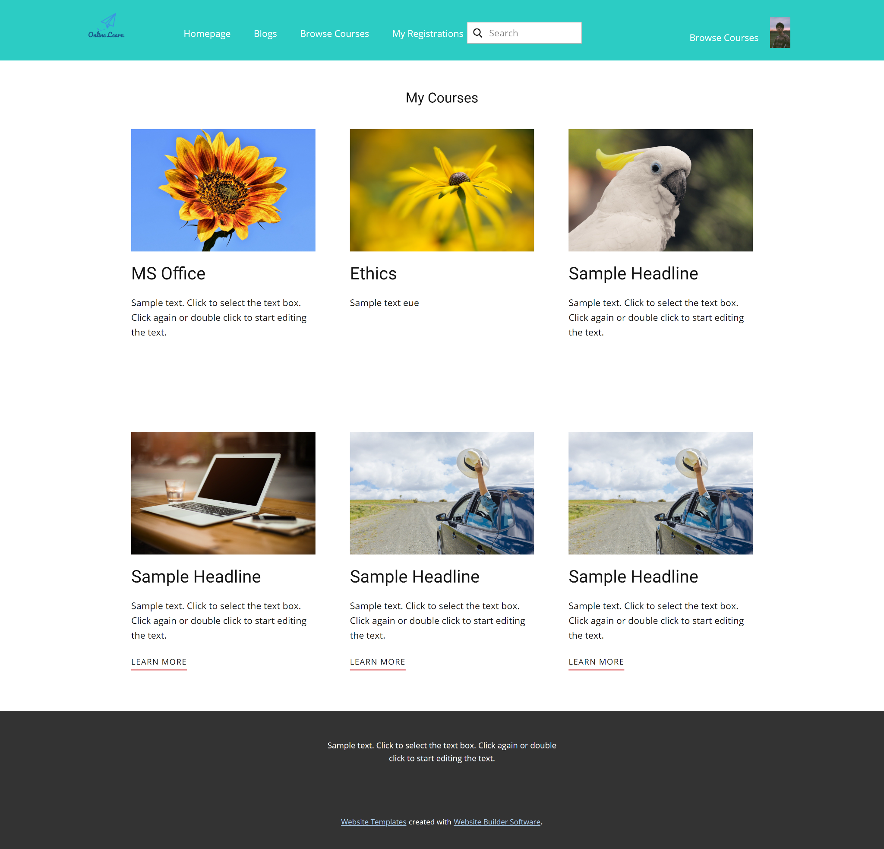
* Function Details: for the customer to view his/her access-allowed courses
  1. **Lesson View**
* Function trigger: when user start studying, open a lesson link
* Function description: allow customer to access the course lessons for his/her studying
* Screen Layout:

Screen layout with lessons list

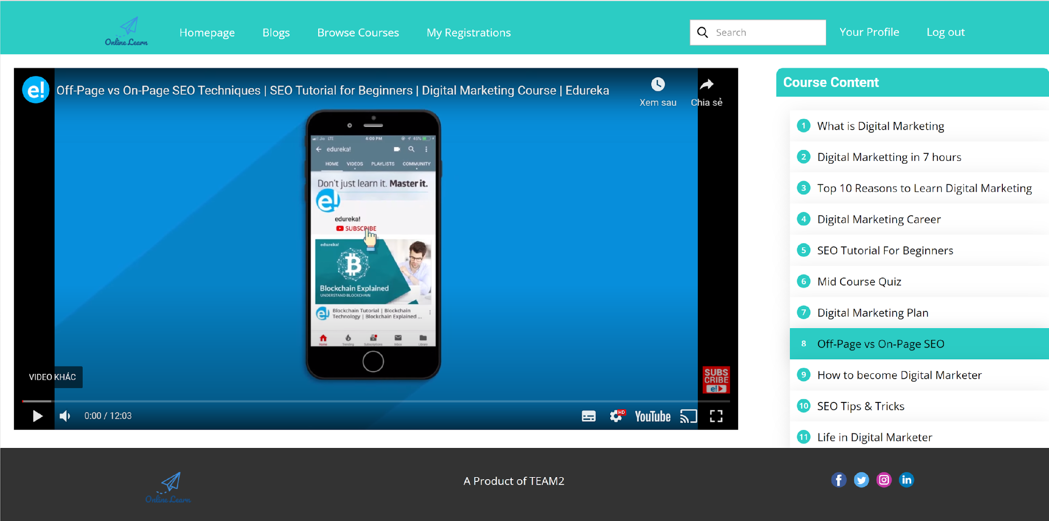

If user choose a HTML-format lesson, the HTML content would be shown instead of the video  
If a quiz lesson is chosen, the Quiz Lesson screen would be shown as described Quiz lesson below

* Function Details: allow customer to access the course lessons for his/her studying

| **Screen Details** | | | |
| --- | --- | --- | --- |
| **#** | **Field Name** | **Type** | **Description** |
| 1 | Course Lessons | Button | This hyperlink links Lesson View screen, with video of that lesson |
| 2 | Embedded Youtube Video | Video | Lesson Video |
| 3 | Course Content | Label | a Label |
|  |  |  |  |

| **Main flows** | | |
| --- | --- | --- |
| **Step** | **Actor** | **Action** |
| 1 | Customer | Click “Continue” of a course in my course page |
| 2 | System | Display the current lesson that customer have stayed, if this is the first time customer take this course, system display the first lesson of the course |
| 3 | Customer | Click a lesson |
| 4 | System | Display that lesson with following video |

* 1. **Quiz Lesson**
* Function trigger: when user click a quiz lesson from a course
* Function description: This allows the user to take the topic quiz or view the quiz results.
* Screen Layout:

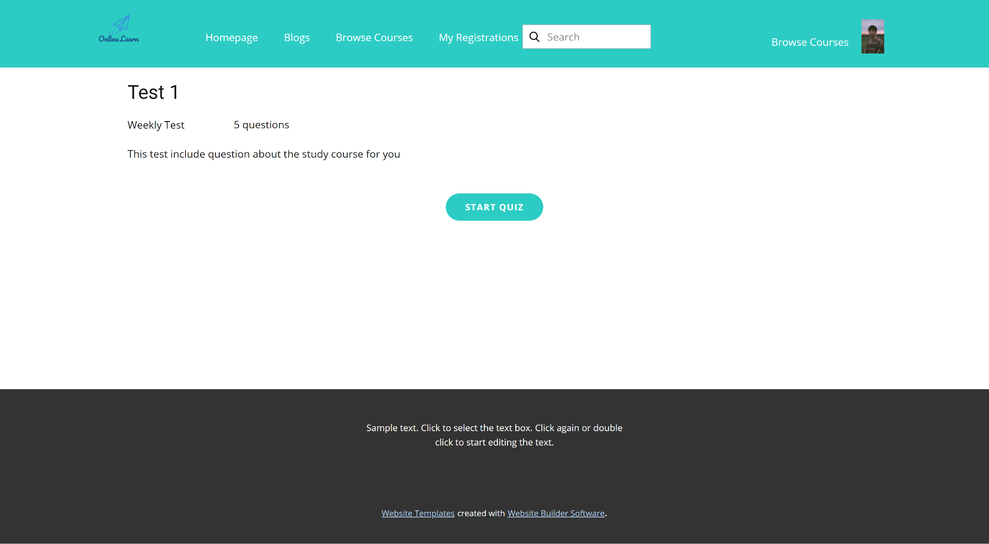

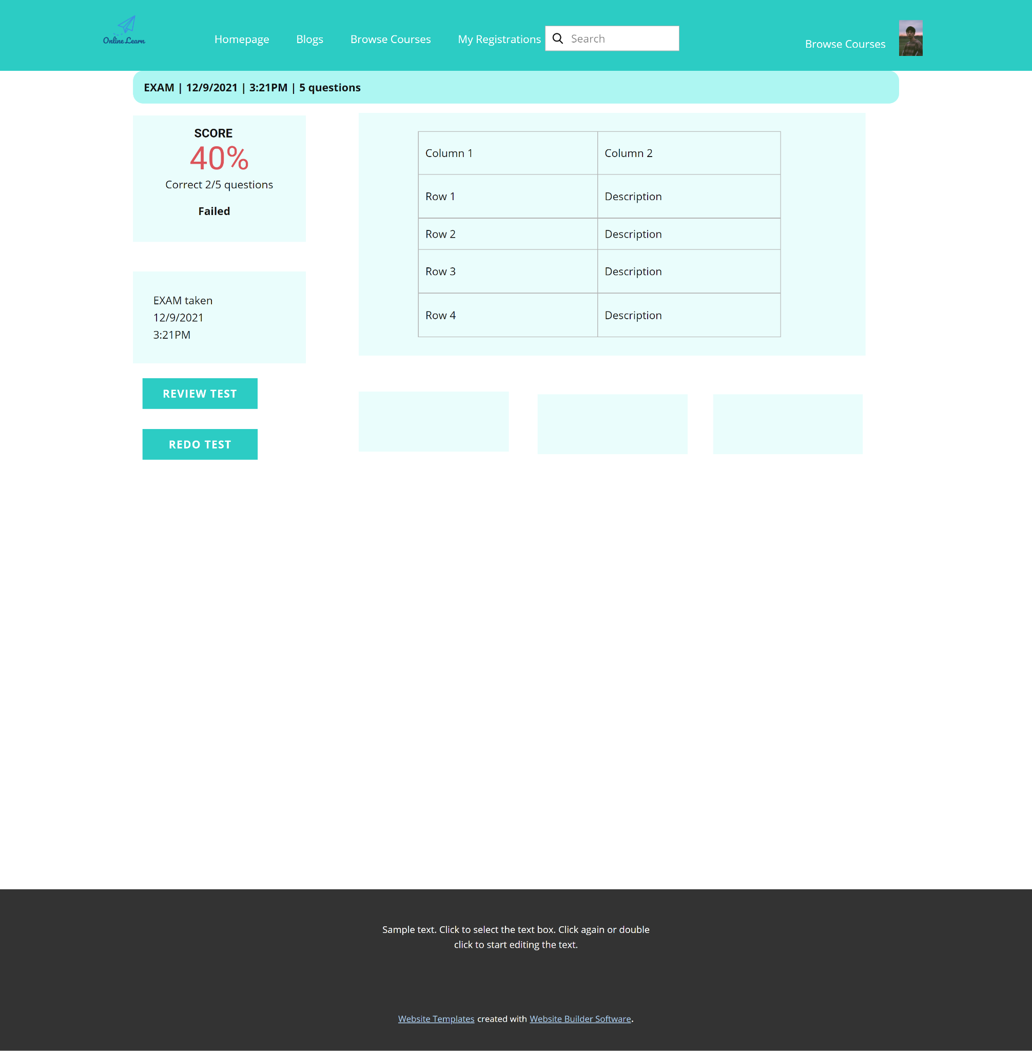

* Function Details: This allows the user to take the topic quiz or view the quiz results

1. **Learning Features**
   1. **Quiz Handle**

* Function trigger : Click to Start Quiz button.
* Function description : Let user do the quiz with multiple choice question.
* Screen layout :

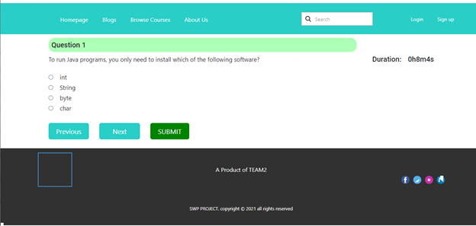

* Function details :
* System will redirect the user to the Quiz Handle page automatically after clicking the Start Quiz button.
* The question of the quiz is multiple choice.
* The duration of the quiz is calculated by the number of hard, medium and easy types of questions. For hard type, it takes 2 minutes per question, medium type takes 1.5 minute and east is 1 minutes
* If at the end of time, the user has not finished the quiz yet then the system will submit the quiz automatically.
* Users can click the button Next to do the next question or button Previous to back to previous question.
  1. **Quiz Review**
* Function trigger: after the test is taken, this show up
* Function description: allows the user to review the details of the quiz that s/he has just taken.
* Screen Layout: This screen allows the user to review the details of the quiz that s/he has just taken. The screen layout is as below

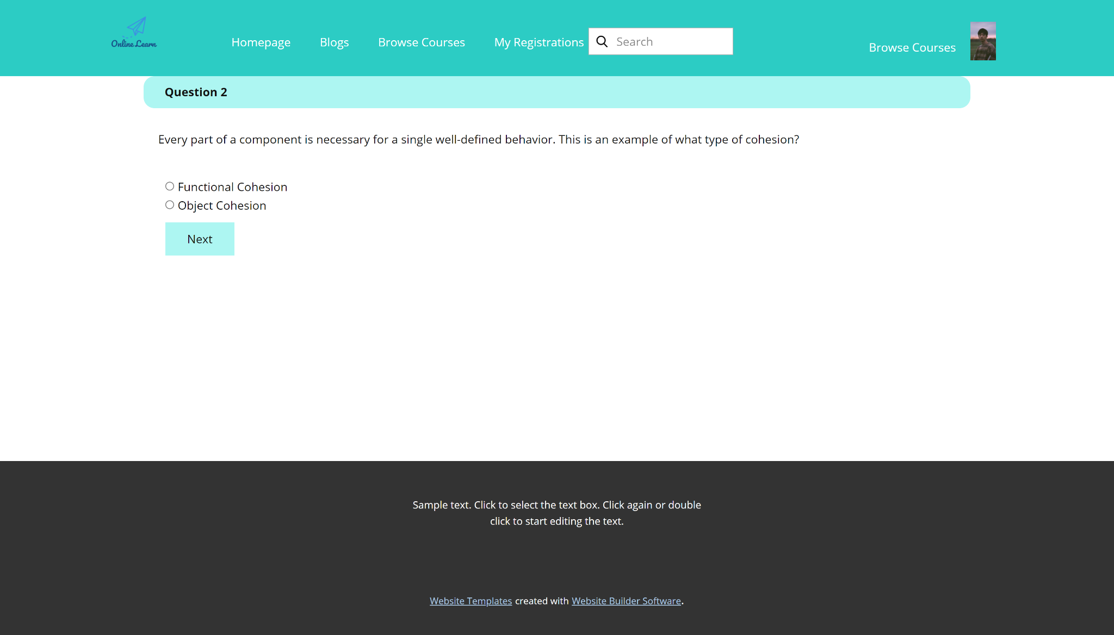

The Explanation button is available only when the question is attached with un-empty explanation  
When the user clicks the Review Result button, the below pop-up screen would be shown with 4 options Marked, Answered, Incorrect, and All Questions with which, the user can filter relevant question numbers to show. By clicking on each question number, the user is redirected back to the Quiz Review screen and at the chosen question.

When the user clicks the Explanation button of the Question Review screen

* Function Details: This screen allows the user to review the details of the quiz that s/he has just taken.

1. **Marketing Features**
   1. **Dashboard**

* Function trigger: by clicking dashboard on Homepage
* Function description: This is for the Admin, Sale or Marketing to see and lookup for the relevant management statistics in the system, with the relevant links to the related screens.
* Screen Layout:
* 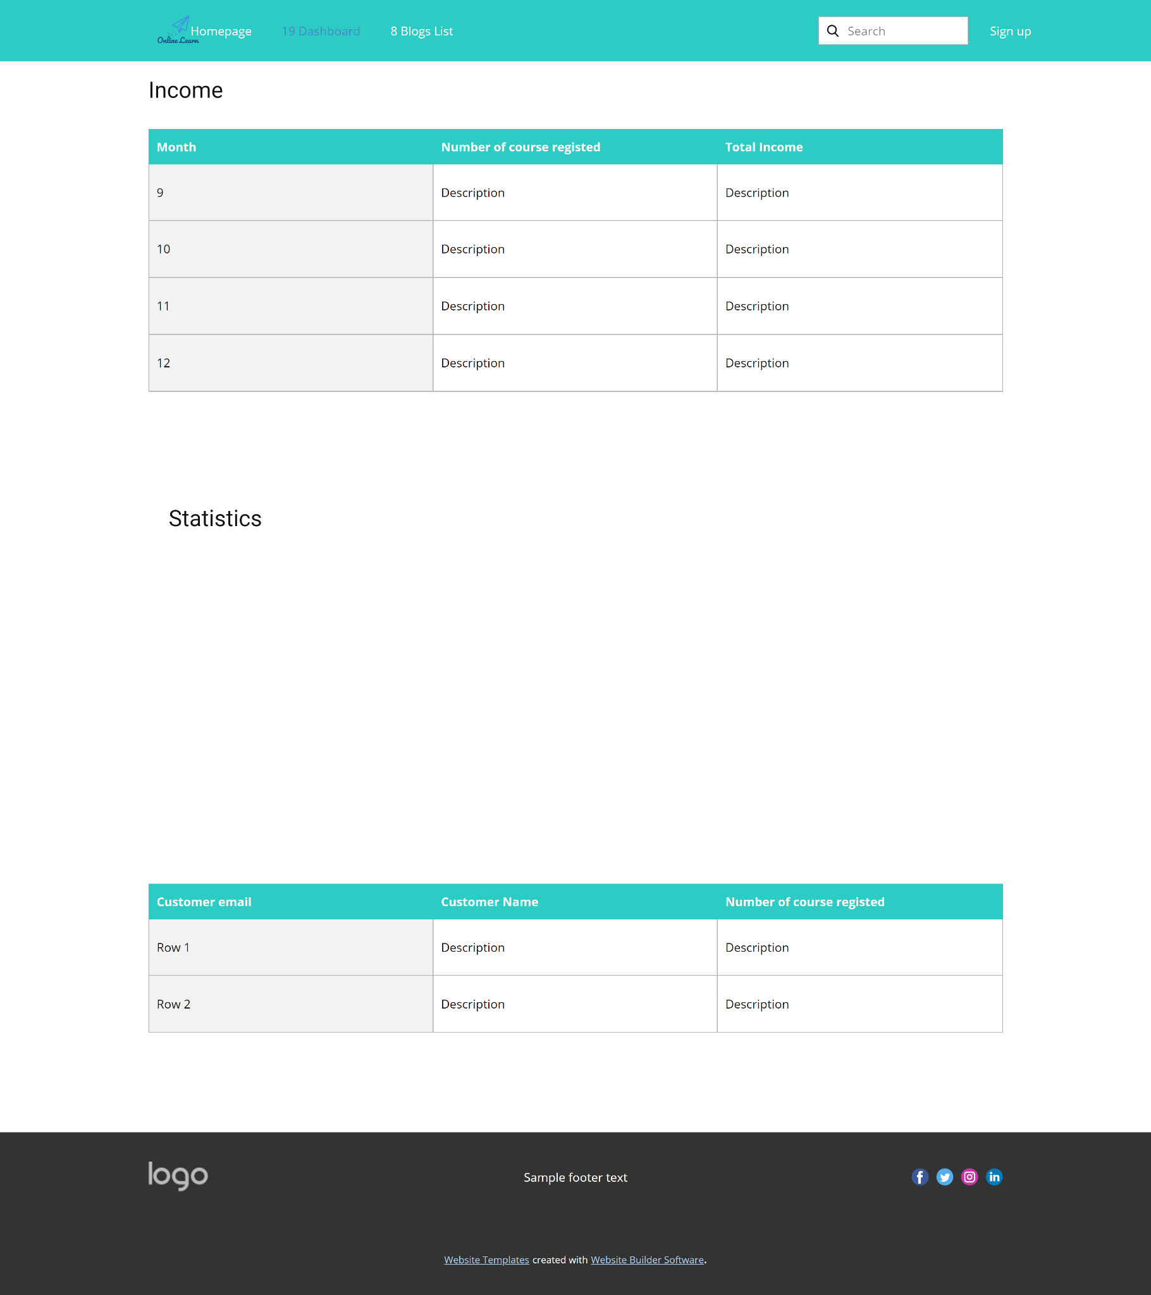
* Function Details: Show statistics of new subjects (new, all), new registrations (success, cancelled, submitted), revenues (total, by subject categories), customers (newly registered, newly bought), and the trend of order counts (success, all) by day for the last 7 days (the start date & end date can be adjustable)
  1. **Post Details**
* Function trigger: Click to Detail at Post list page
* Function description:View Post detail
* Screen Layout:
* 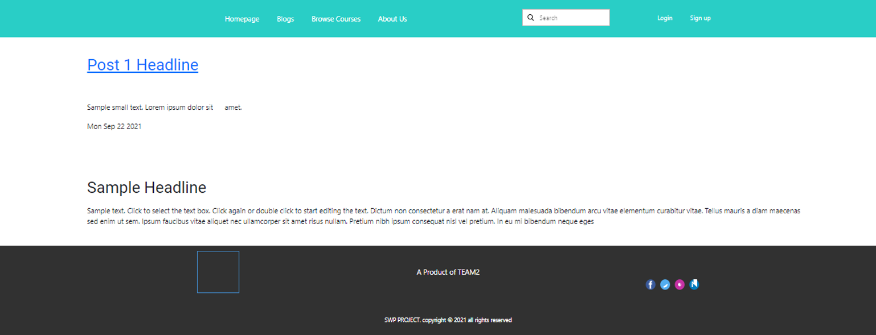
* Function Details:
* System will redirect user to Post Detail page automatically after click to the Detail.
* User view post detail includes headline, author, date created
  1. **Slider List**
* Function trigger: Click on slider button in menu
* Function description: list, filter, search, show, hide, view, add new or edit existing slider(s)
* Screen Layout:

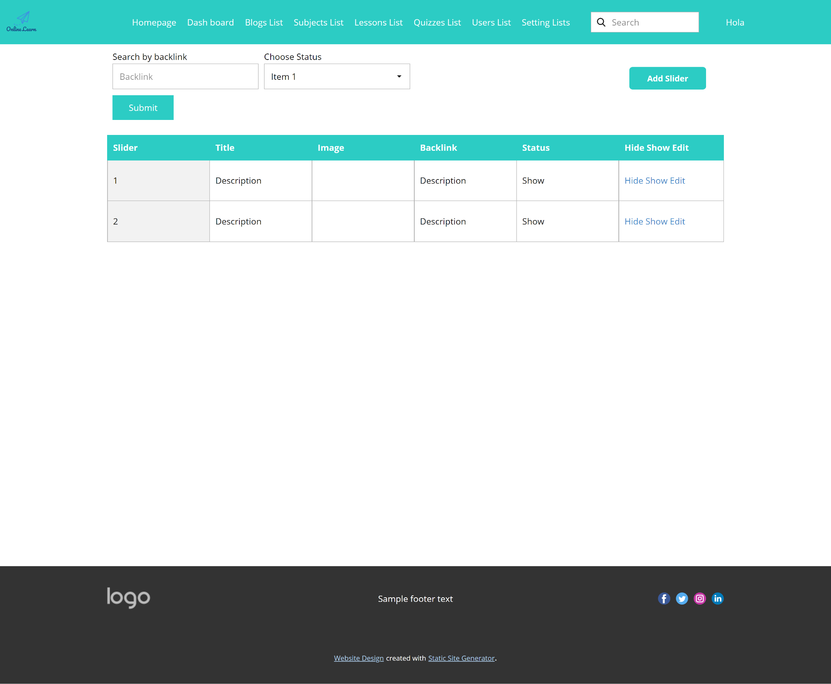

* Function Details: "Show the paginated list of sliders (including sliders' id, title, image, backlink, status)
  + The user can filter the sliders by the status + search by title or backlink
  + For each slider, the user can choose to hide, show, edit it"
  1. **Slider Details**
* Function trigger: clicking the link of the slider on Slider List page
* Function description: view & edit the details of a specific slider
* Screen Layout:

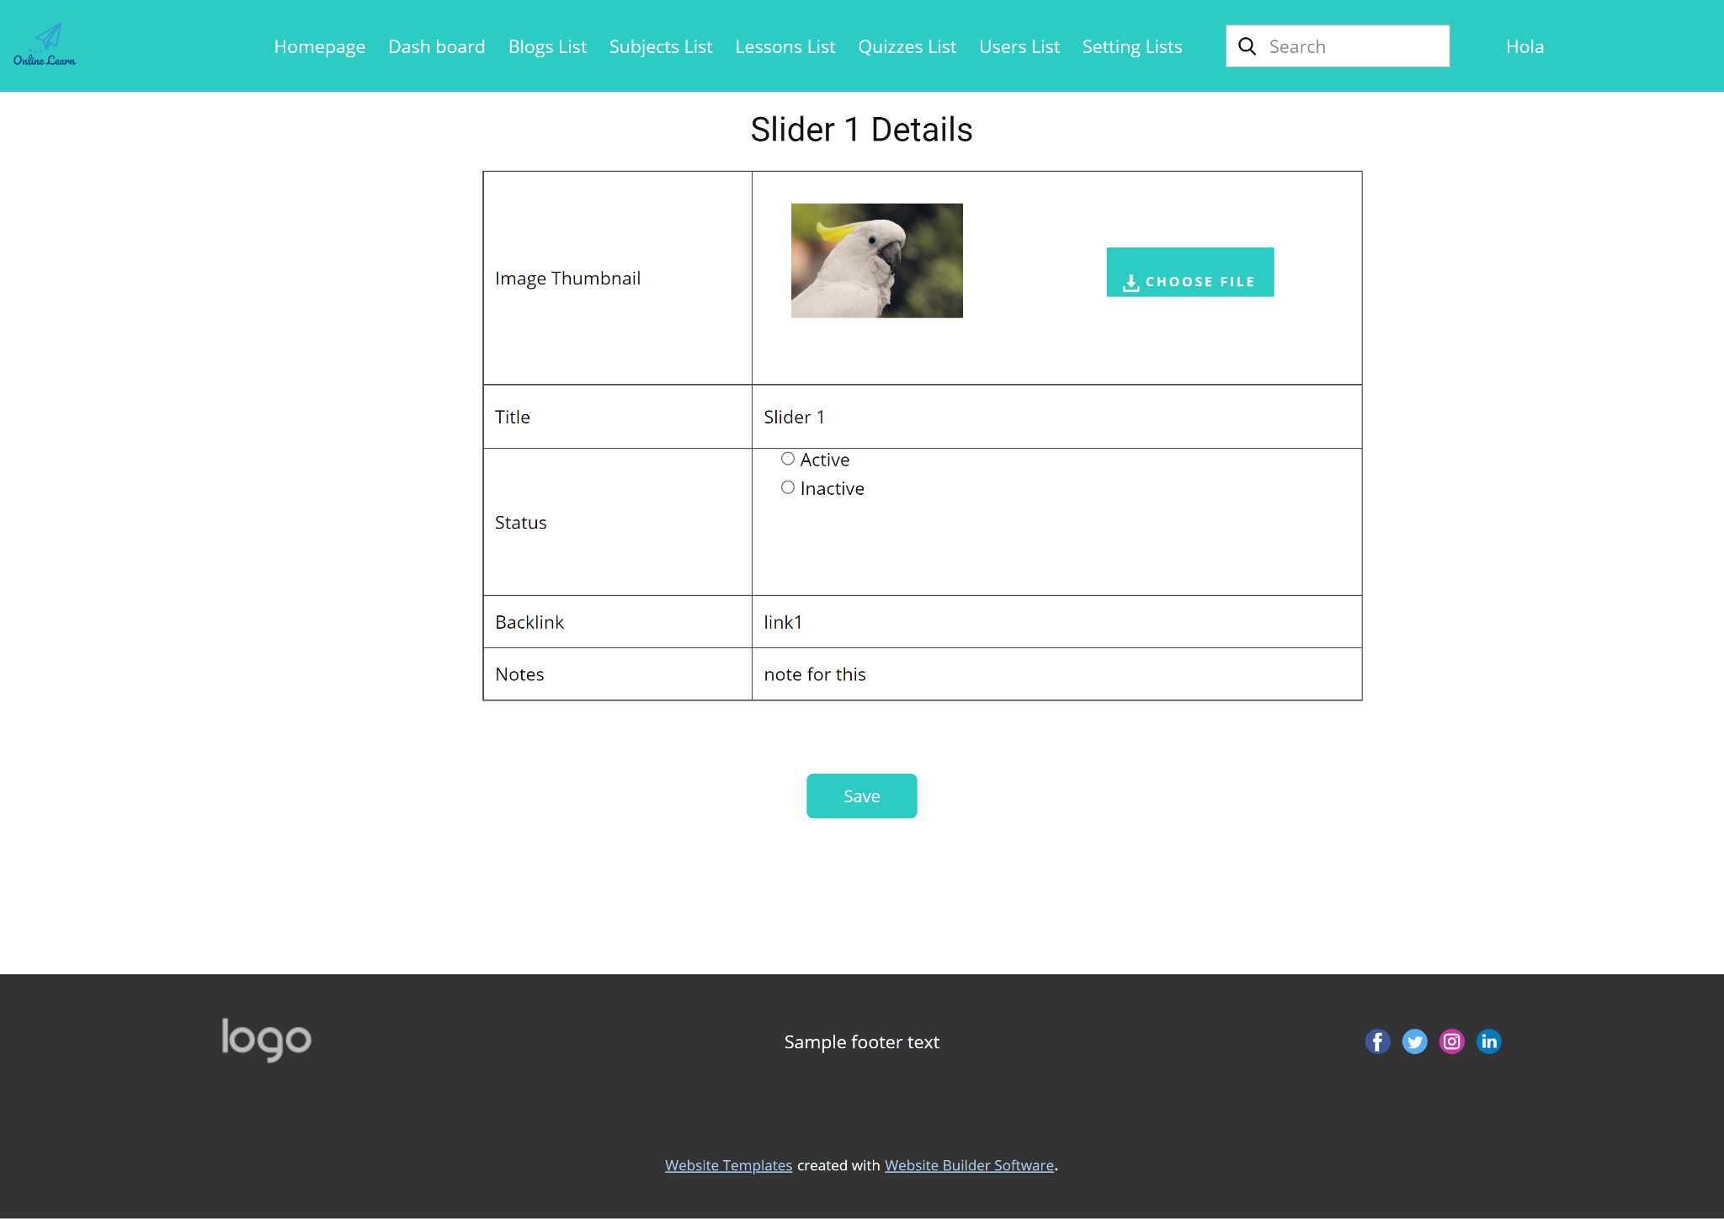

* Function Details: Show detailed slider information (image, title, backlink, status, notes)

1. **Course Content Features**
   1. **Subjects List**

* Function trigger: click the “subject list” link from admin/expert homepage
* Function description: This screen allows the admin and expert to see the existing course list. The admin can see all the courses while the expert can only see his assigned courses
* Screen Layout: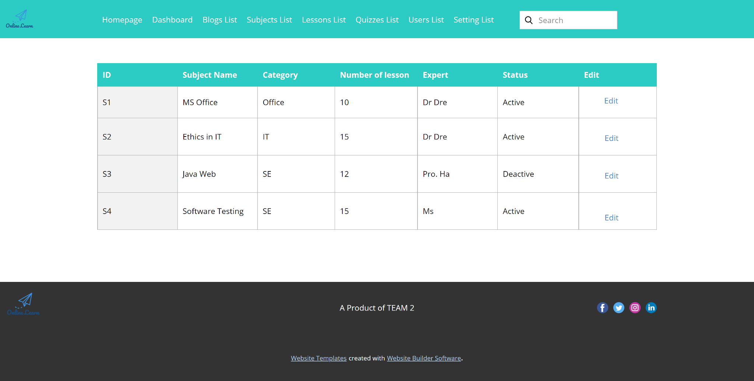

* Function Details: "Show the list of course paginated. The shown information for each subject include the id, name, category, number of lessons, owner, and status
  + - The user can:
  + Filter the list by course category & status
  + Search the course by the name
  + Choose to add new course (redirect the user to the New Subject page for that)
  + Edit course information (linked to the Subject Details for that)"

* 1. **New Subject**
* Function trigger: in the subject list screen, Click to button Add Subject
* Function description: This screen allows the admin to add new course and assign the expert (owner) for further course content preparation
* Screen Layout:

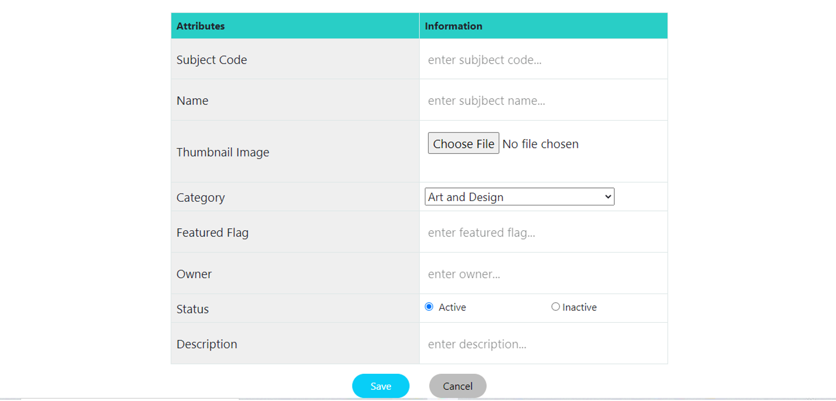

* Function Details:
* System will redirect user to Add New Subject page automatically after click to the Add Subject button.
* User have to input Subject Code, Subject Name, Thumbnail Image, Category, Featured Flag, Owner, Status, Description.
* Subject Code cannot be blank and be unique.
* Subject Name cannot be blank.
* Owner cannot be blank.
  1. **Subject Details**
* Function trigger: after click a subject from Subject list
* Function description: This page allows the admin and the assigned expert to access and prepare the subject information, including the course general information, the dimension, and price package. And add/edit the price packages
* Screen Layout: The screen layouts are as below (for 3 tabs of the screen). With the admin, the Overview tab also displays the owner (expert) information, from that s/he can change the owner if needed.

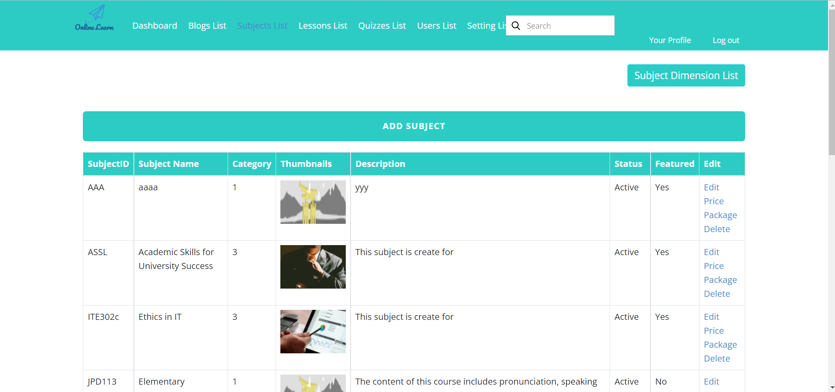

Edit Subject:

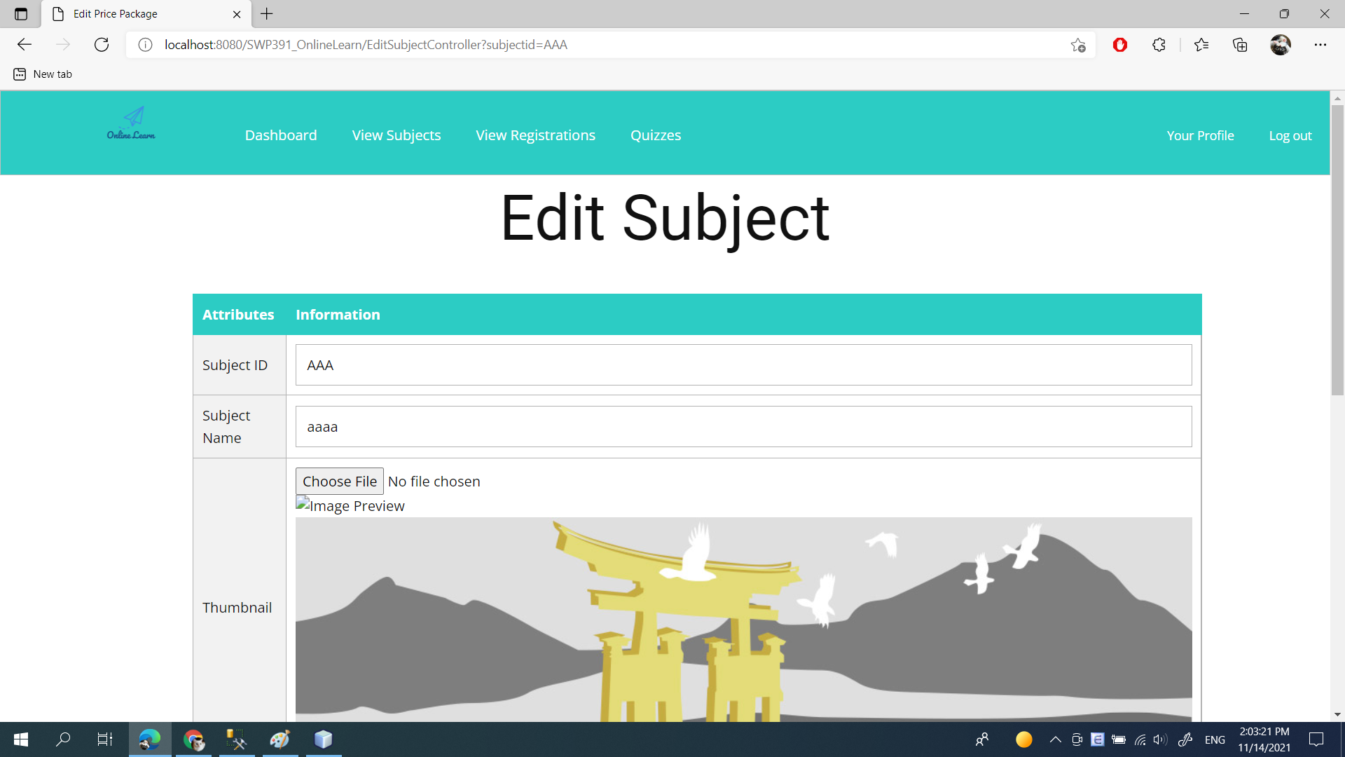

* Function Details: This page allows the admin and the assigned expert to access and prepare the subject information, including the course general information, the dimension, and price package. Only the admin can change the status to Published or Unpublished + add/edit the price packages
  1. **Subject Dimension**
* Function trigger: Click edit/add in action column in dimension tab
* Function description:
* Screen Layout:

Dimension List:

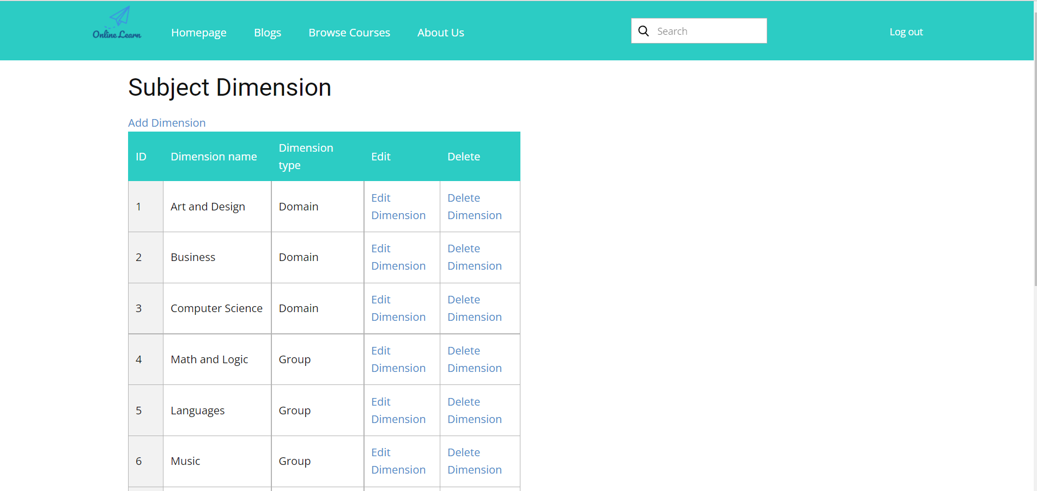

Add dimension:

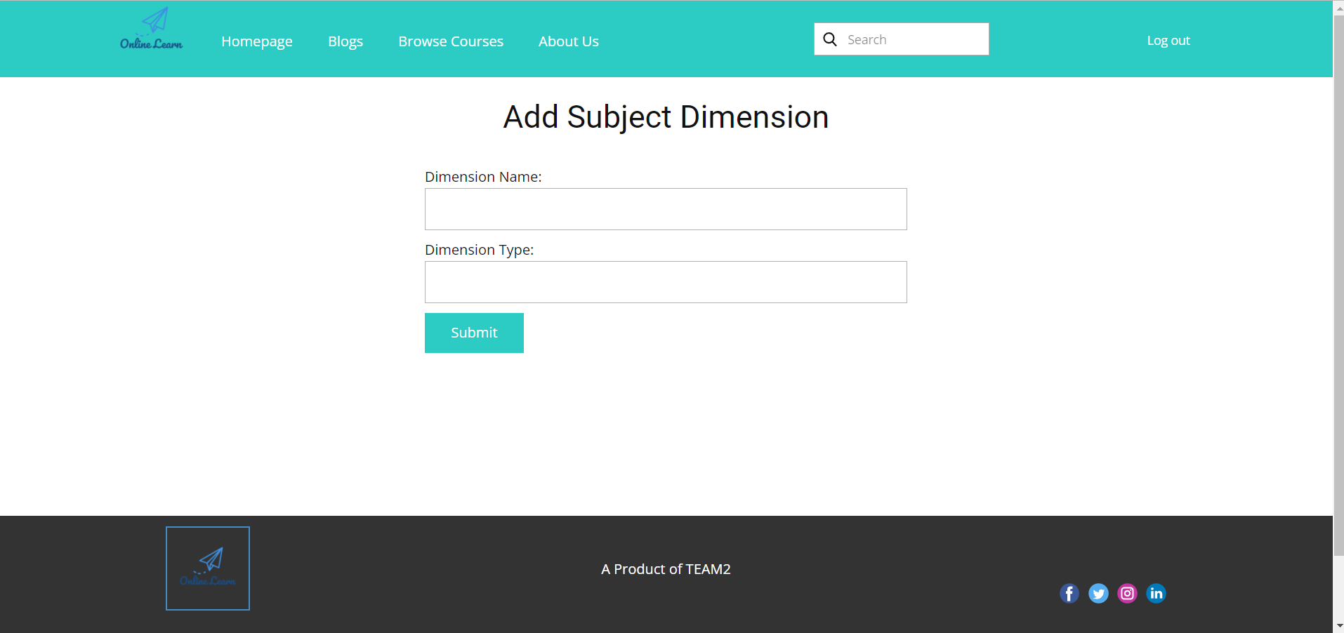

Edit dimension:

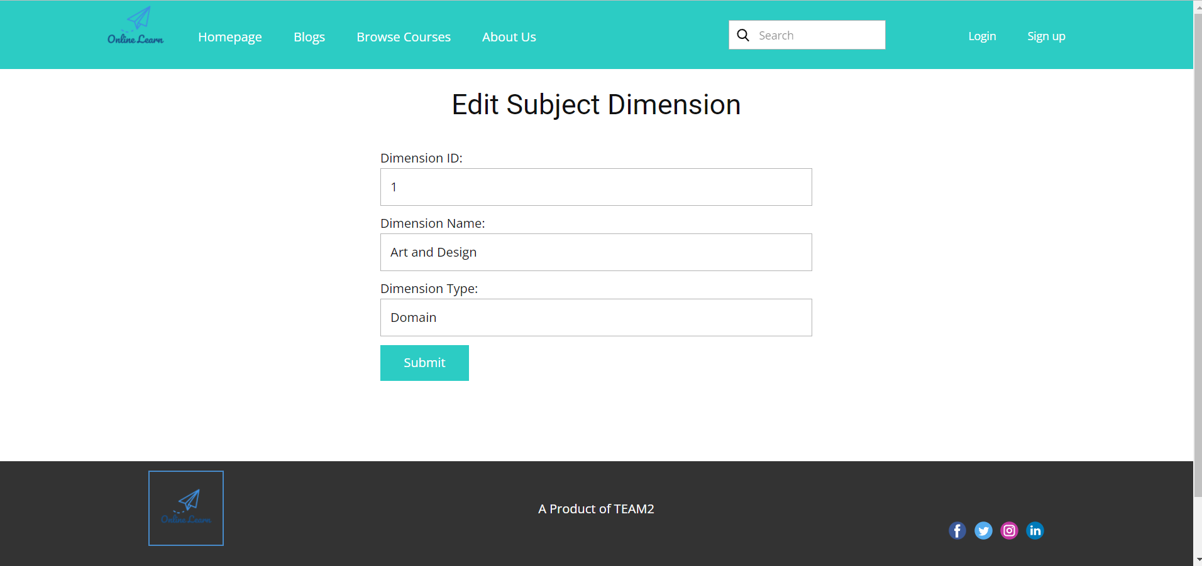

* Function Details: This page allow the admin/expert to input or edit subject dimension information, including the following detailed information: type, name, description
  1. **Price Package**
* Function trigger: when user click on link”edit” or “add new” from price package window
* Function description:
* Screen Layout

Price Package List:

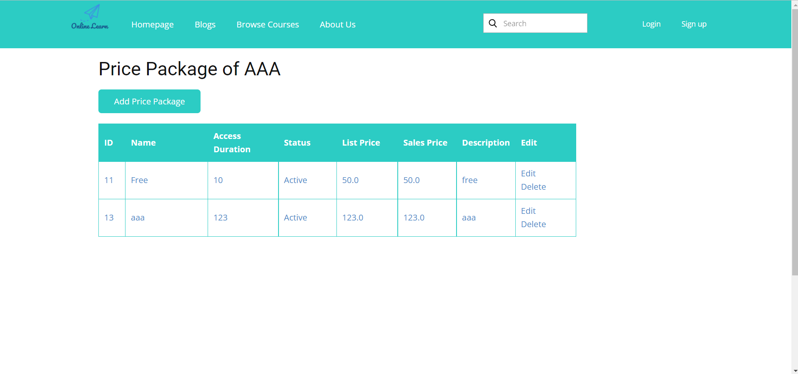

Edit Price Package:

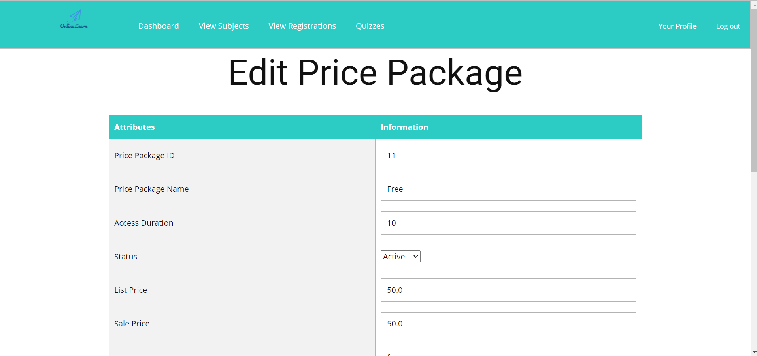

Add Price Package:

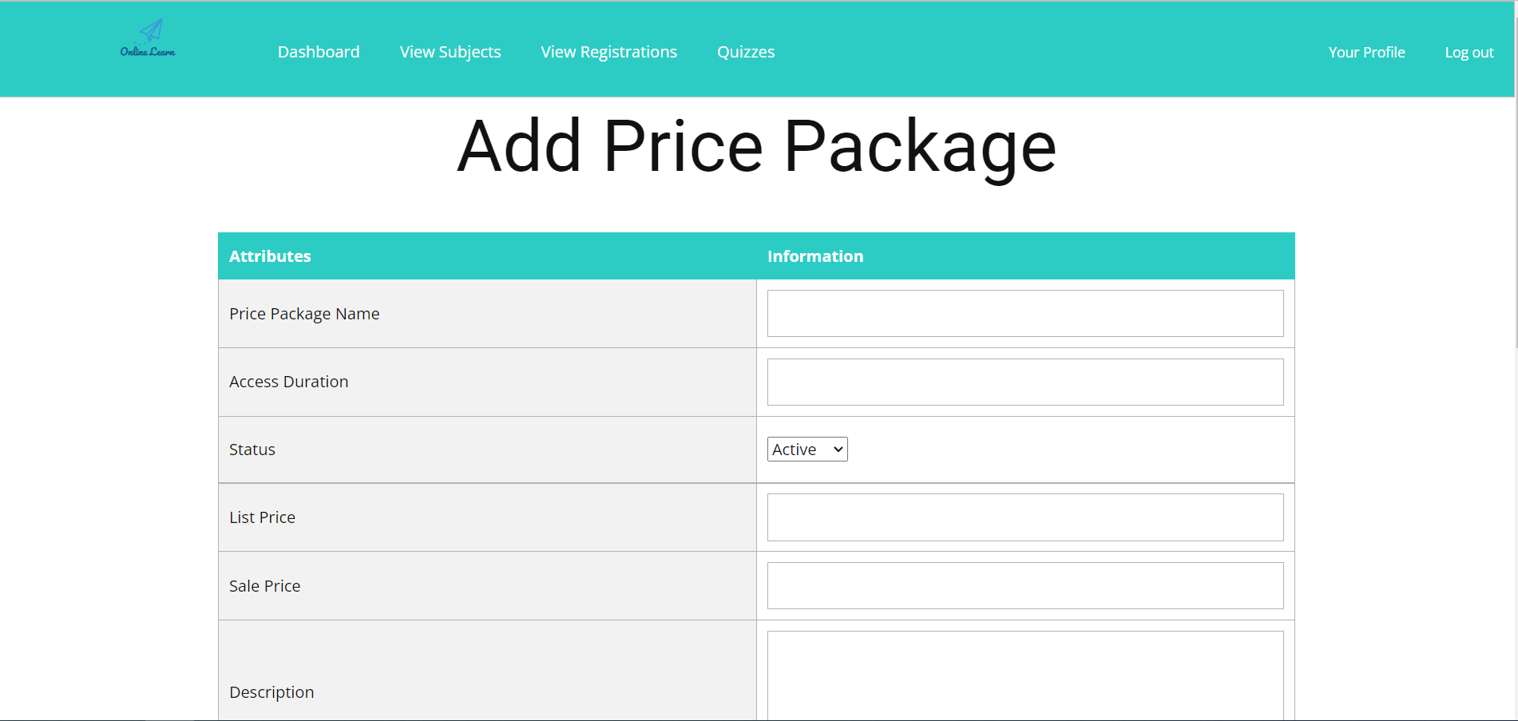

* Function Details: This page allows the admin to input or edit subject dimension information, including the following detailed information: name, access duration (in months), status (read-only), list price, sale price, description. The expert can only view the information.
  1. **Subject Lessons**
* Function trigger: click on “Lessons” from a subject
* Function description:
* Screen Layout:

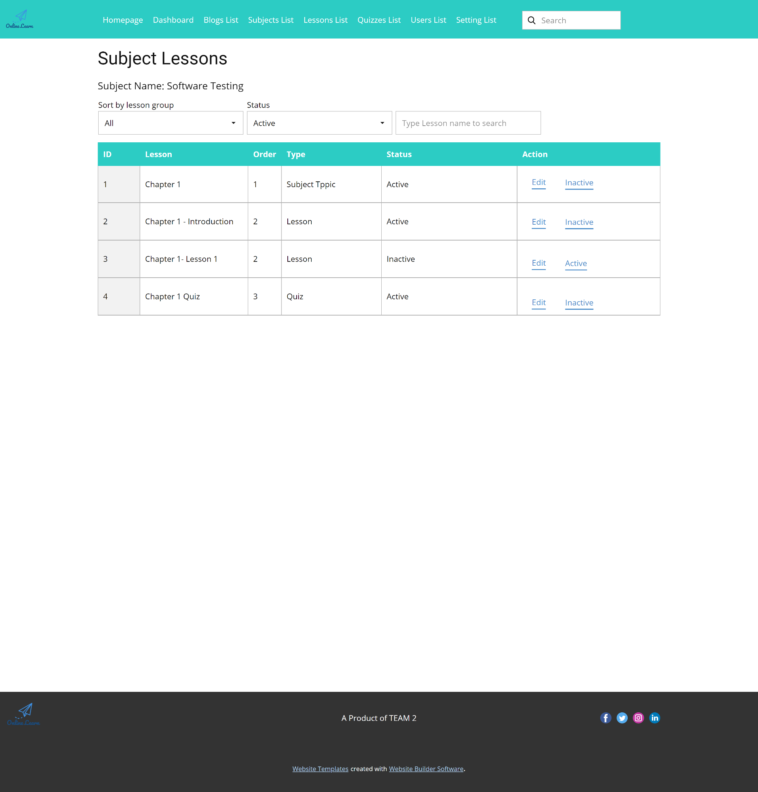

* Function Details: This page shows the list of lessons for a selected package. On this page, the admin/expert is allowed to activate/deactivate, or call the Lesson Details for adding new or editing existing lesson
  1. **Lesson Details**
* Function trigger: Click to Detail at lesson list page.
* Function description: View lesson detail and change lesson detail.Screen Layout:

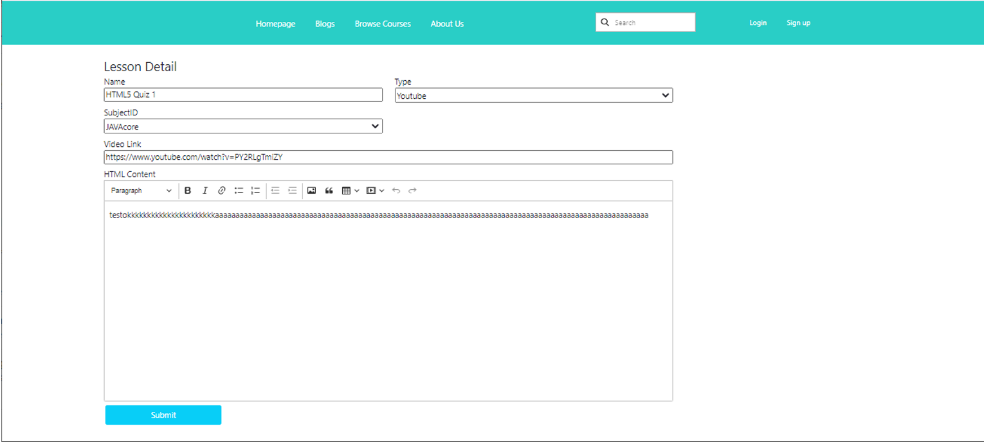

* Function Details:
* System will redirect user to Lesson Detail page automatically after click to the Detail.
* User can change Lesson name, type, subjectID, Video link, Content by change the value in text box and click button submit

1. **Test Content Features**

This feature includes the functions that allow the admin and expert to prepare the testing related contents (the questions bank & quizzes list)

* 1. **Questions List**
* Function trigger: When click Question List from a quiz
* Function description:
* Screen Layout:

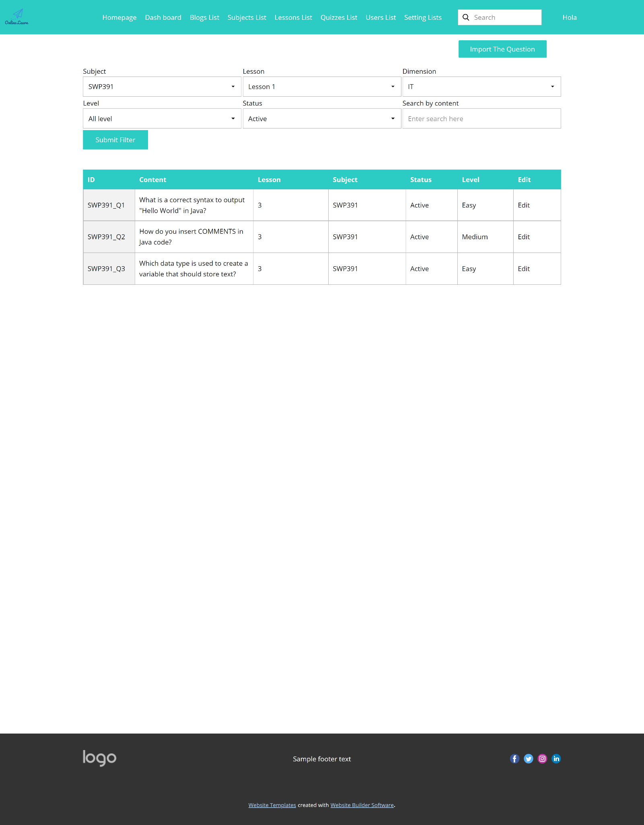

* Function Details: The existing questions list for a specific subject/course are shown here (paginated). On this screen, the admin/expert is allowed to filter the questions by the subject, lesson, dimension(s), level, status + search the questions by content

Below information is shown for each question in the list: id, content, subject /dimension /lesson, level, status + options to show, hide, edit it; The page also allows the user to import the question (redirect him/her to the Questions Import pop-up screen.

* 1. **Question Details**
* Function trigger: When click edit on same row with chosen question from the Question List
* Function description:
* Screen Layout:

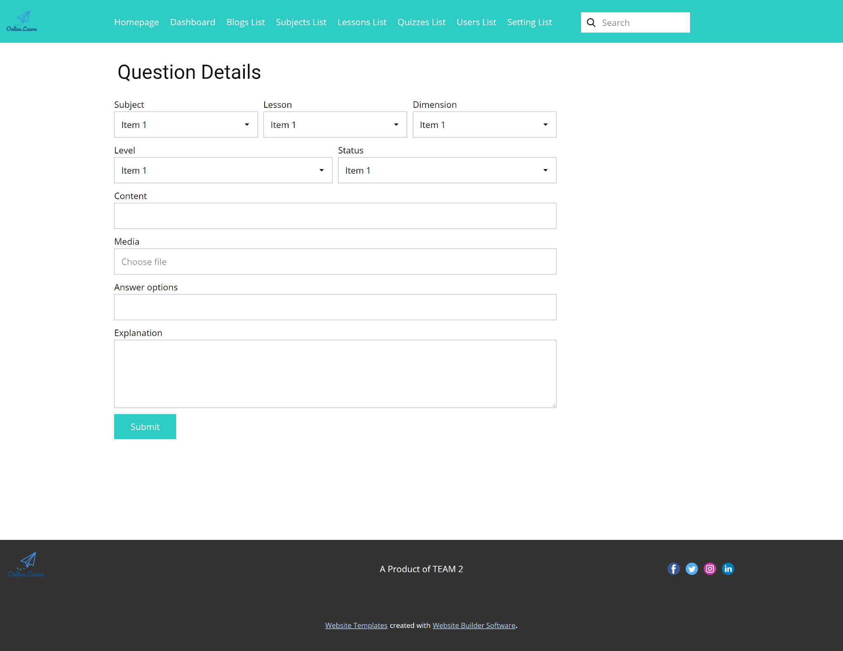

* Function Details: This page allows the admin/expert to input or edit questions information, including following information: subject, dimension(s), lesson, status, content, media (image, audio, video – with preview option), answer options (with the key marked + ability to add, edit, delete), and explanation
  1. **Question Import**
* Function trigger : Click to item Import Quiz at header menu of manager page .
* Function description : This page allows manager import quiz follow the provided format
* Screen layout

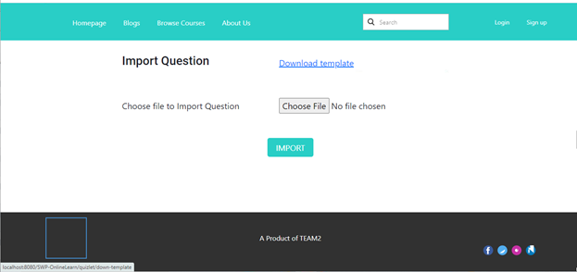

* Function Details:
* Before making a file to import. Users can download the format first by clicking the link Download template.
* The import file must be an excel file.
* After choose file to import, click to Import button
  1. **Quizzes List**
* Function trigger: click quizzes list from menu
* Function description:
* Screen Layout:

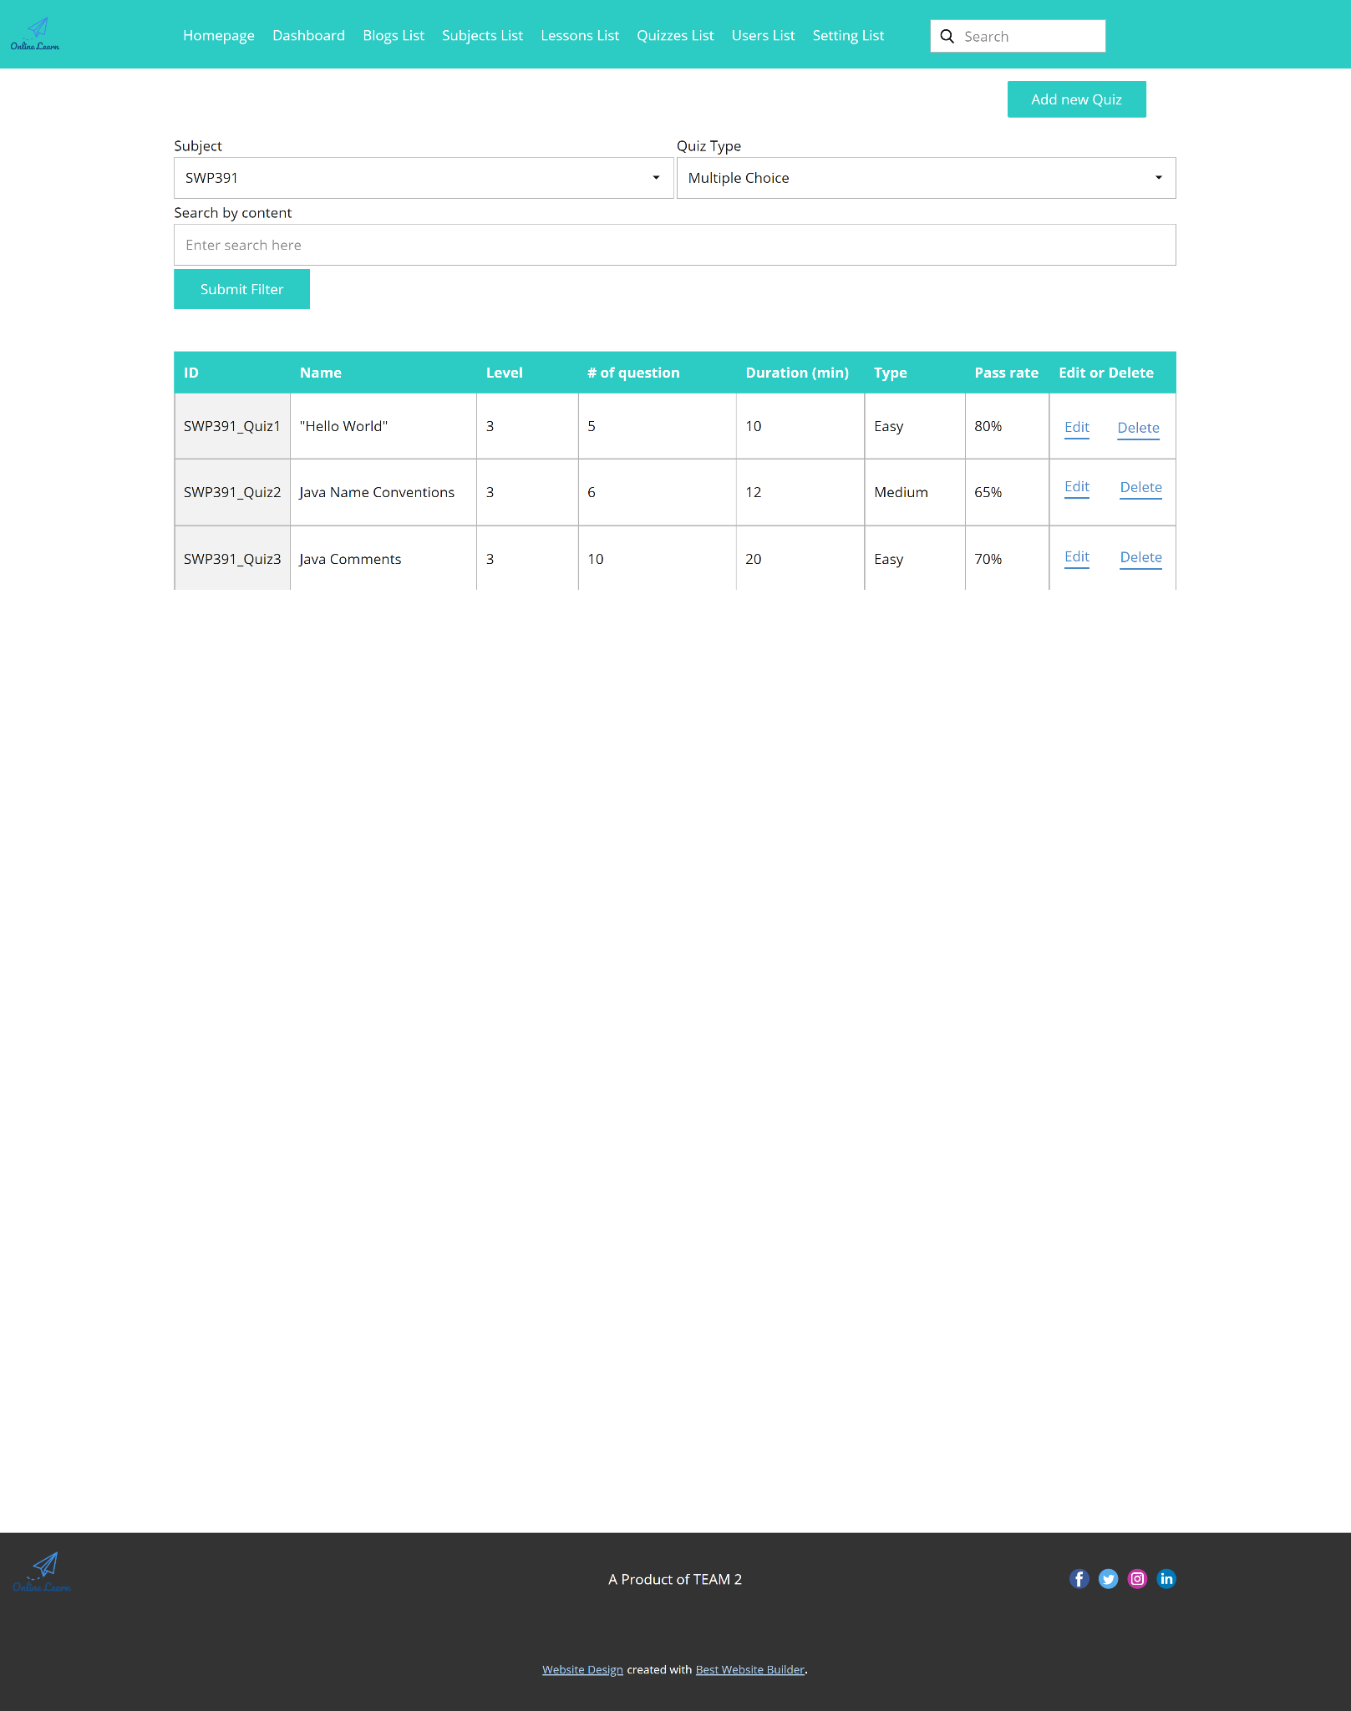

* Function Details: "The existing quizzes are shown in this page pagination:
  + The user can filter the list by subject, quiz types + search quizzes by the name
  + Each quiz includes following information: id, name, subject, level, # question, duration, pass rate, and the quiz type.

From this page, the user has the option to call to the Quiz Details page for adding new or editing existing quizzes + delete the quiz. Please note that the quiz can be edited only when there is not any test taken yet."

* 1. **Quiz Details**
* Function trigger: When Click edit from above screen
* Function description: This page allows the user to input or edit quiz information.
* Screen Layout:

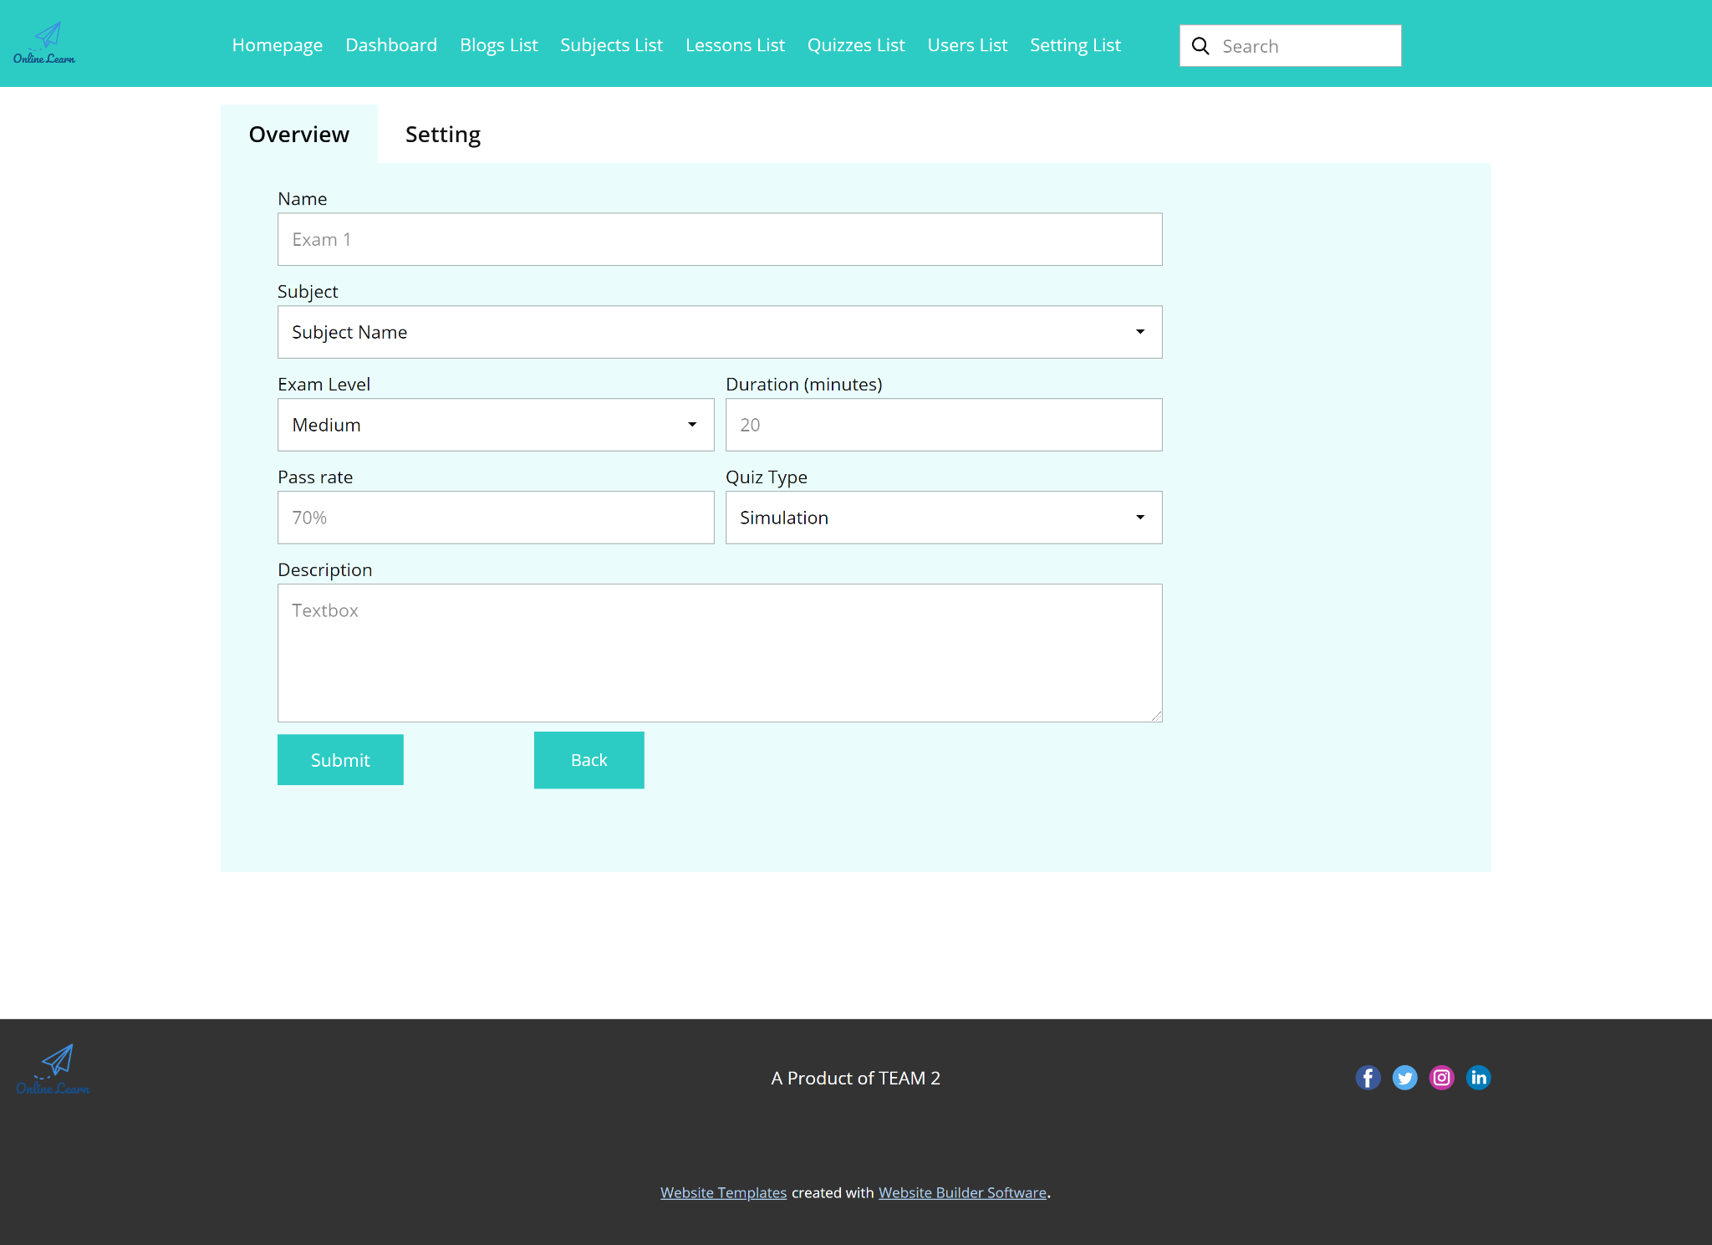

* Function Details: This page allows the user to input or edit quiz information

1. **Sale Features**

This includes the screens used for sale persons

* 1. **Registrations List**
* Function trigger: when click Registration List from Homepage
* Function description: Show the list of users' registrations
* Screen Layout:
* Function Details: "Show the list of users' registrations
  + Each registration includes below information: id, email, registration time, subject, package, total cost, status, valid from, valid to, last updated by;
  + The list can be sorted by id, email, registration time, subject, package, total cost, status, valid from, valid to

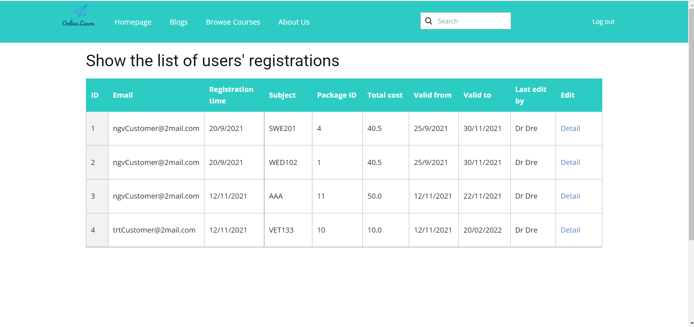

* 1. **Registration Details**
* Function trigger: when click edit from above screen
* Function description:
* Screen Layout:

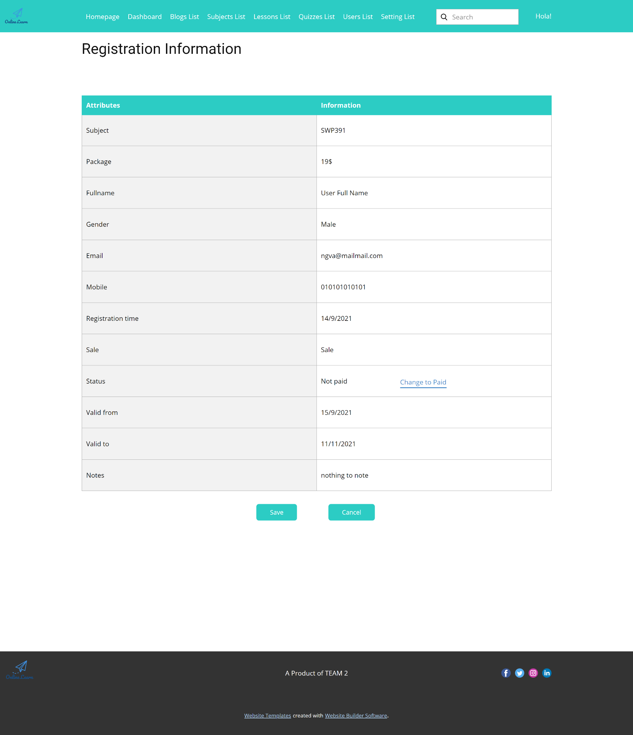

* Function Details: Show detailed registration information (subject, package with list price/sale price, full name, gender, email, mobile), registration time, sale, status, valid from, valid to, notes) from that for the user to add new or change the status of a registration with relevant notes (if a registration is created by the user, then s/he can edit other registration information). On changing a registration status to Paid, if the user with relevant registered email does not exist, the system would create one and send back to the user the login information (link, email, pass) along with the other notification notes

1. **Admin Features**

The Admin feature includes the screens used for the organization manager and system  
administrator, as listed below

* 1. **User List**
* Function trigger: when click “User List” from Homepage
* Function description: list, filter, search, show, hide, view, add new or edit existing user(s)
* Screen Layout:

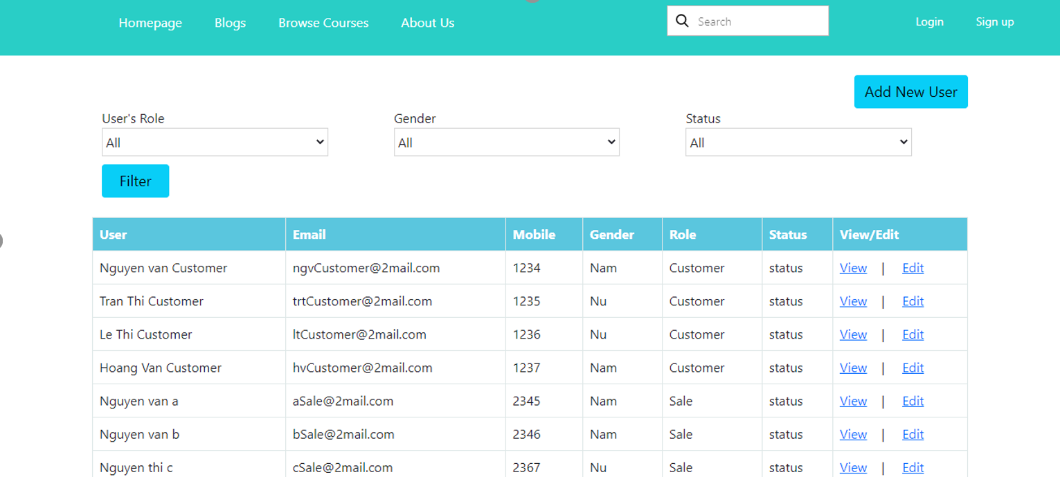

* Function Details:
* System will redirect the user to the Register User List page automatically after clicking to the user list button.
* Display FullName, Email, Mobile, Gender, Role, Status.
* Data is split into pages, each page has 7 items.
  1. **User Details**
* Function trigger: when click “View or edit” link from above window
* Function description: view & edit the details of a specific user
* Screen Layout:

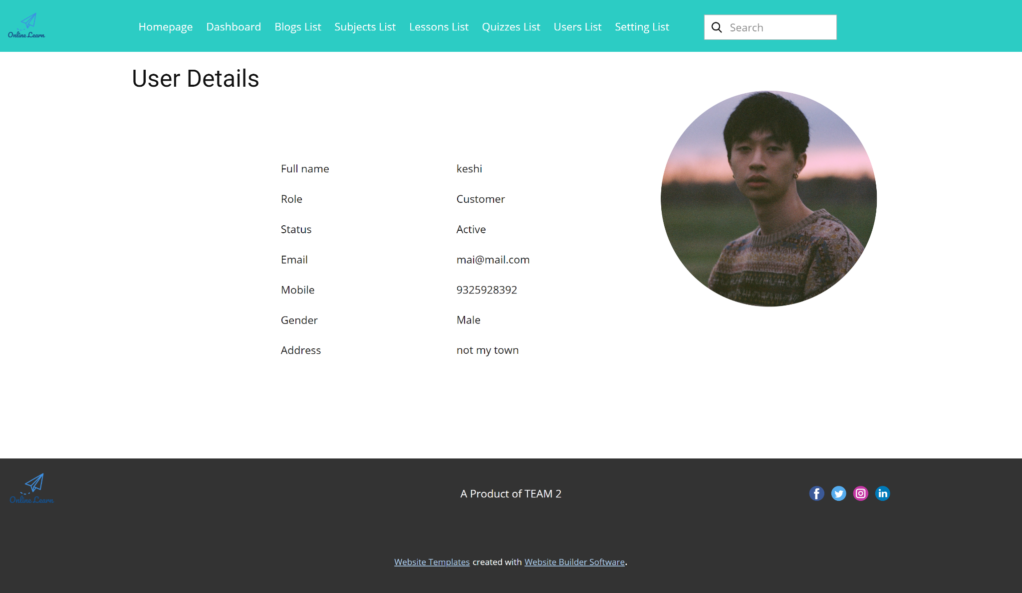

* Function Details: "Show detailed user information (avatar, full name, gender, email, mobile, role, address, status), from that allow the user to add new, view or edit user information
  + After adding, new generated login password would be email to the new user
  + The admin can only edit/update the role and status of the user"
  1. **Setting List**
* Function trigger: when click “Setting List” from menu Homepage
* Function description: list, filter, search, show, hide, view, add new or edit existing system setting(s)
* Screen Layout:

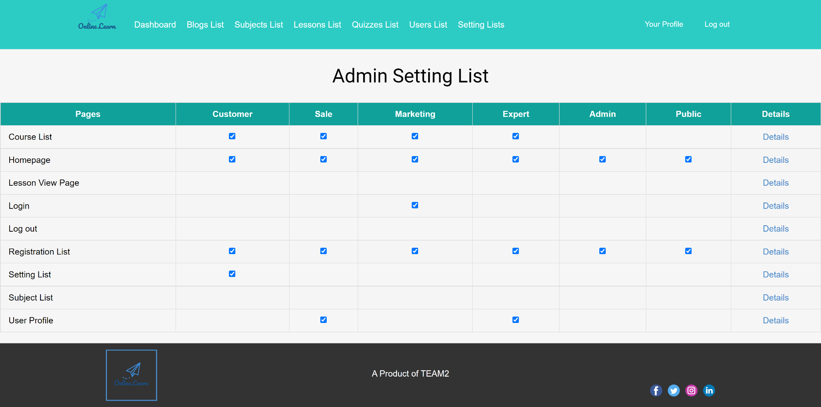

* Function Details: Show who have right to access each page

| **Screen Details** | | | |
| --- | --- | --- | --- |
| **#** | **Field Name** | **Type** | **Description** |
| 1 | Table Header | Label | Show list role of system |
| 2 | Details | Hyperlink | This hyperlink links to the “Setting Details” page of that URL |
| 3 | Admin Setting List | Label | Name of this screen |
| 4 | Checkbox | Checkbox | If a role can use a Url, checkbox of the following cell is checked |

| **Main flows** | | |
| --- | --- | --- |
| **Step** | **Actor** | **Action** |
| 1 | Admin | Click “Setting List” in header |
| 2 | System | Display the list of setting list screen |
| 3 | Admin | Click Details |
| 4 | System | Redirect to “Setting Details” |

* 1. **Setting Details**
* Function trigger: when click “Edit” from above screen
* Function description: view & edit the details of a specific system setting
* Screen Layout:

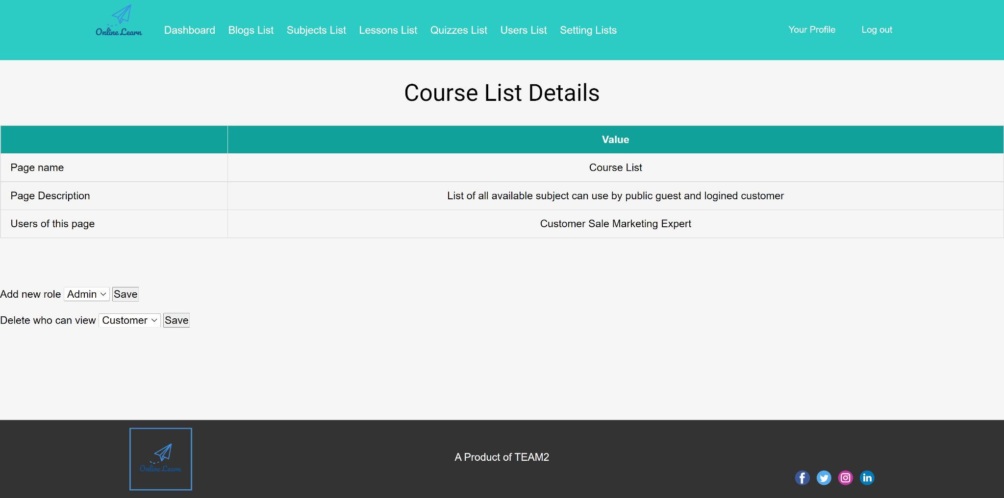

* Function Details: Show detailed user information (type, value, order, description, status), from that allow the user to add new, view or edit setting information

| **Screen Details** | | | |
| --- | --- | --- | --- |
| **#** | **Field Name** | **Type** | **Description** |
| 1 | Course List Details | Label | Name of this screen |
| 2 | Table | Table | Basic information about url, list of user who have access to that url |
| 3 | Add new role | Form | Add new role who can access this page url |
| 4 | Delete who can view | Form | Remove a user from access this page |

| **Main flows** | | |
| --- | --- | --- |
| **Step** | **Actor** | **Action** |
| 1 | Admin | Click “Details” of a Page in “Setting List” page |
| 2 | System | Display the Setting Details page |
| 3 | Admin | Click a lesson |
| 4 | System | Display that lesson with following video |

Alternative flows: Add user

| **Step** | **Actor** | **Action** |
| --- | --- | --- |
| 1 | Admin | Choose a User to access page |
| 2 | System | Add that user |
| 3 | System | Go to Setting List Page |

Alternative flows: Delete user

| **Step** | **Actor** | **Action** |
| --- | --- | --- |
| 1 | Admin | Choose to remove a user from access page |
| 2 | System | Remove that user |
| 3 | System | Go to Setting List Page |